QualityRights Gujarat
A service provider’s perspective
Bilkish Patni’s story
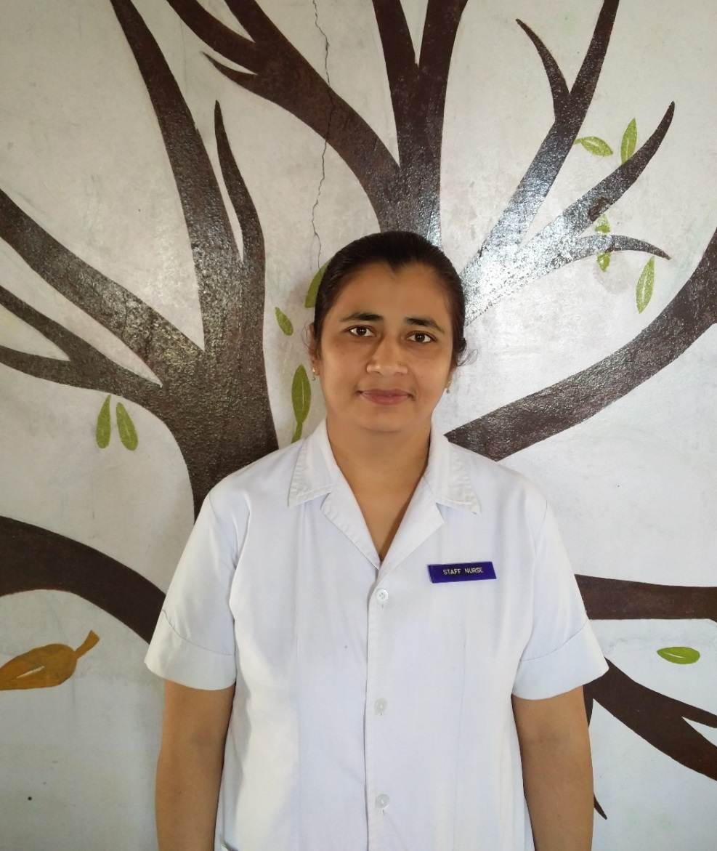
Ms. Bilkish Patni has been working as a nurse at the Hospital for Mental Health, Bhuj since September, 2015. Before being transferred to this service, she worked at several different general health facilities. Prior to working there Ms Patni had already visited the hospital in her youth. She recalls: “My mother was a 4th class servant at this hospital… and I had visited the hospital when I was young. All of us have a pre conceived sketch of a mental hospital in our heads. And I perceived it the same way… patients would be constantly locked inside. The windows would be shut. They would call out to people from the windows and the doors. When people came inside the hospital, they would run towards them. So in my head there was a sketch- inside a mental hospital, patients are locked up inside rooms and cells”.
Because of this pre-conceived idea as well as her first-hand experience, she hoped to never return. “When I was told that I am being transferred to the mental hospital, I was shocked. I wondered what I would do there! Even my colleagues told me that I am too sensitive for a mental hospital. They told me that if I spend too much time there, I will become like them – my expressions will be like theirs and that I will become thoughtless.”
When she first came to work at the hospital, she had a certain understanding of her role as a staff nurse –- “When I came here, I was told that when the patients come down after their meals, they are supposed to be given medicines. This is what our role is… whatever the doctor prescribes or orders us to do, we have to follow.”
Ms. Patni joined the hospital during the intervention phase of QualityRights Gujarat and was able to participate in the training on mental health and human rights and on recovery oriented mental health care being delivered by staff members who have been trained to become QualityRights master trainers. “When I started participating in the QualityRights training sessions I started enjoying my work.”
Her understanding of her role as a staff nurse also broadened. She says “Just giving people medicines from time to time is not our job… but sitting with them and talking to them is a part of our job. In fact I think, I consider smiling at them and also making them feel comfortable as a part of our job. It does make an impact…After the training I realised that we must work according to the patients’ needs - what they want. For example, practices are not necessarily bound by rules or time- it is 1 o clock, it is time for lunch so they must eat and then have their tablets. It does not work that way! …Now I understand that medicines are not the only thing. Developing a relationship and a bond with the patients and understanding them is necessary. This is what I learnt – that I am not a dummy, and that I also can think, understand patients’ needs and then work accordingly.”
Bilkish Patni further describes how the training has brought about a change in herself and her work; “The turning point would be the training sessions. During each training I would have a parallel thought running in my head – if I am here… then there is a lot I can do. I had completely suppressed my interests, which started opening up through these trainings. I realised that I feel good by practising this way.
Another change is in the way that Ms. Patni thinks about how people using mental health services should and should not be treated. “There is also a change in the way I think about patients. You know tying patients up, or putting them inside locked rooms is NOT ok… this has changed, ever since I first came to the hospital. How to listen to the patients, understand their needs and respond to their needs while maintaining boundaries is important…”.
About the training on mental health and human rights, she remarks “We didn’t know too much about rights. We knew that we had rights.. But in the trainings we realised that they have rights too! We all share the same rights… that changed a lot for me. We would think that these people are pagal (mad) and hence, cannot do a lot of things… but a lesson on rights changed the way we thought. These trainings MUST be ongoing… they MUST continue.”
The development of improvement plans within the service, in combination with the training staff have received, has resulted in some major changes at the hospital.
“See. earlier we used to keep our patients all locked up inside. As this program started and the staff started receiving all the trainings, there was a change in them… They started getting the patients out of their wards. As they came out of their wards, their level of activity increased… they started playing, they started getting involved in the daily activities… they started praying. They also started getting to know what THEIR interests are… “
In conclusion, Bilkish Patni remarks: “I do believe that I can continue with what I have learnt through these trainings. I see myself as a person who now actively engages with all the issues at the hospital, especially those that concern the patients. I do see myself as a voice for those patients who confide in me. I do see myself as someone who can fight along with them, irrespective of the challenges and constraints I face, as a person and at the hospital”.
********************
Collaborators on the QualityRights Gujarat project include the Centre for Mental Health Law and Policy ILS Pune, World Health Organization Geneva, CAMH Toronto, Hospital for Mental Health Ahmedabad, Schizophrenia Awareness Association, Pune, SCARF Chennai and Public Health Foundation of India (PHFI) New Delhi.

This Project is supported by Grand Challenges Canada. Grand Challenges Canada is funded by the Government of Canada and is dedicated to supporting Bold Ideas with Big Impact ® in global health.

