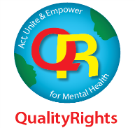
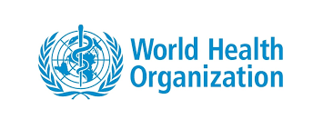

MINISTRY OF HEALTH

REPORT ON LAUNCH OF QUALITYRIGHTS MENTAL HEALTH INITIATIVE IN KENYA HELD AT KENYATTA INTERNATIONAL CONFERENCE CENTRE ON THURSDAY, 21ST NOVEMBER 2019

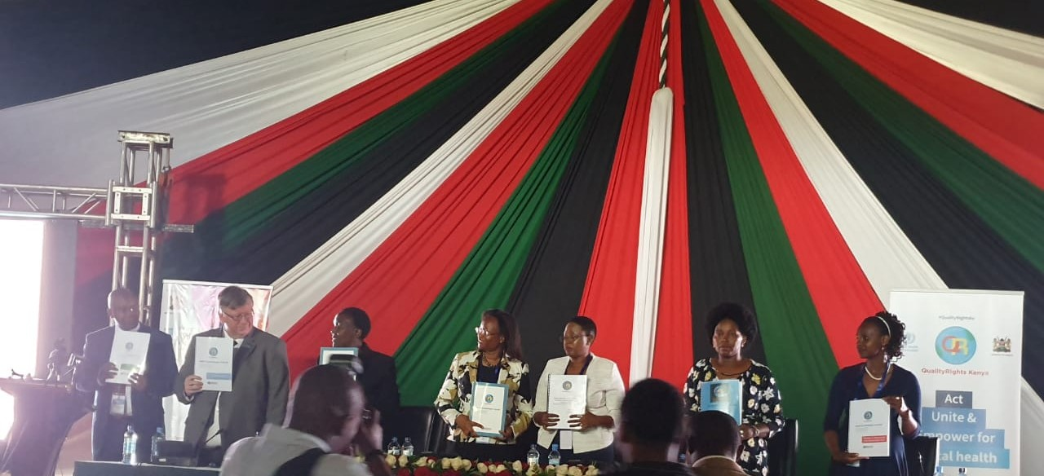

1.0 Introduction
The World Health Organization (WHO) QualityRights initiative aims to increase access to good quality mental health services and support and to protect the rights of people with mental health conditions, psychosocial, intellectual and cognitive disabilities. It has several major objectives including to: 1)build capacity among mental health professionals and other health workers, people with lived experience, families, carers and other supporters, Non-Governmental Organizations (NGOs) and organizations of people with disabilities on how to implement a human rights and recovery approach in the mental health and social care fields in line with the United Nations Convention on the Rights of Persons with Disabilities (CRPD), 2) to assess, improve, transform existing services and to create new ones so that they promote a person centered, recovery and human rights based approach 3) to support the development of civil society to advocate for human rights based approach in mental health and related areas and to 4) reform policy and law in line with international human rights standards.

As part of its initiative, WHO has developed the QualityRights training programme which encompasses an e-training platform and face to face training modules on mental health, human rights and recovery. This initiative will greatly enable the ministry to achieve the Kenya Mental Health Policy Goal; to attain the highest standards of mental health. The WHO QualityRights assessment Toolkit is designed for application in low, middle and high income resource settings and is well aligned with the Kenya Vision 2030, the medium-term plan agenda on Universal Health Coverage and our commitment to international obligations and goals.

As part of the implementation of the QualityRights mental health initiative in Kenya, a launch was held at the Kenyatta International Conference Centre on Thursday, 21st November 2019 during the Kenya Mental Health Conference.
The event was attended by four hundred and fifty (450) participants drawn from all over the country. This included representatives from corporate bodies, NGOs & Civil Society Organizations (CSOs), other organizations, mental health professionals and other health professionals. People with lived experience with psychosocial, intellectual and cognitive disabilities, caregivers and a cross section of the general public.
The launch was presided over by the chief Guest, Principal Secretary, Ministry of Health – Susan N. Mochache, CBS together with other invited guests who included:
- Dr Rudi Eggers - WHO country representative
  - Hon Sabina Chege – Woman Representative, Murang’a county, Chairperson Parliamentary Health Committee
  - Hon Gladwell Jesire Cheruiyot – Woman Representative, Baringo County
  - Sylvia Mueni Kasanga – Nominated senator and mental health advocate.
  - Dr Pacifica Onyancha – Ag Director of medical services and Head department of preventive and promotive health, Ministry of Health.
  - Dr Joyce Nato – WHO Country office representative
  - Dr Simon Njuguna – Director mental health, Ministry of Health
1.1 Methodology
A QualityRights coordinating committee was formed in July 2019 during the QualityRights planning meetings. The committee multi-stakeholders membership includes representatives from partners such as Ministry of Health, division of mental health and Health standards, quality assurance legislation and regulations, World Health Organization, Office of Council of Governors, Users and Survivors of Psychiatry in Kenya (USP-K), Kenya National Commission on Human Rights (KNCHR), Basic Needs Basic Rights Kenya, CBM Kenya, Special Olympics Kenya, Kenya Medical Training College, Kenya Health Professional Oversight Authority, State department of social protection, Kenya Law reform commission and Alzheimer and Dementia Association of Kenya (ADOK). The coordinating committee was involved in planning for the launch and found it appropriate for the launch date to coincide with the first annual mental health conference in Kenya.The QualityRights secretariat worked closely with the conference planning committee to plan for the pre-launch activities which included public sensitization, media breakfast meeting and the launch ceremony during the conference. The launch was placed during the plenary session to be launched after the guest of Honor’s speech.

The launch program constituted a presentation by Dr. Simon Njuguna on the QualityRights implementation plan in Kenya and Michael Njenga on CRPD, messages from dignitaries, partners and persons with lived experience, QualityRights video launch followed by a panel session on QualityRights

2.0 Prelaunch activities
Multistakeholder sensitization meeting
A QualityRights stakeholders’ half day sensitization meeting was held on 5th November 2019 at the Kenya National Commission on Human Rights offices. It was attended by 40 participants who included Ministry of Health, QualityRights champions, partners, stakeholders from different organizations – NGOs, CSOs, people with lived experience and those from various media houses.

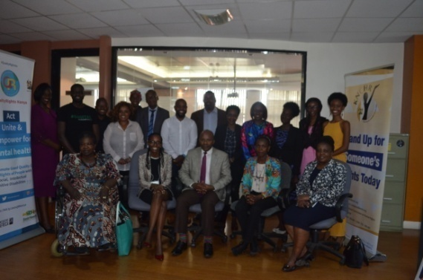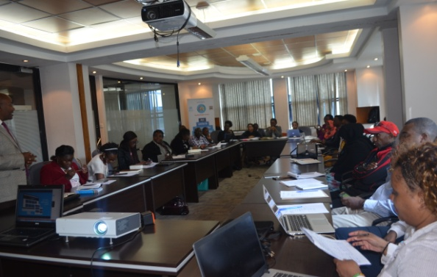

Pre-launch Media Briefing Breakfast
The pre-launch breakfast meeting was held at the National Public Health Laboratory Hall, Block A on 18th November 2019 from 8:00am – 9:30 am. It was attended by 50 people. These included members of the QualityRights coordinating committee, other partners, NGOs, CSOs, people with lived experience and those from various media houses. The meeting began with an introduction on QualityRights, followed by few remarks by various coordinating committee members in attendance on their engagement with QualityRights thus far. Dr. Simon Njuguna, Director mental Health, read a statement on the implementation of QualityRights mental health initiative in Kenya. He highlighted the objectives, 5 thematic areas, activities to be carried out and the expected results.
The video by QualityRights Gujarat was played. After the break of the meeting, the Director was interviewed by the various media houses

2.1 THE LAUNCH CEREMONY
Opening presentation
Quality Rights Mental Health Initiative -Highlights on the World health Organization (WHO) QualityRights mental health initiative with focus on the toolkit themes drawn from the Convention on the Rights Persons with disabilities (CRPD):
- The right to an adequate standard of living and social protection (Article 28 of the CRPD).
- The right to enjoyment of the highest attainable standard of physical and mental health (Article 25 of the CRPD).
- The right to exercise legal capacity and the right to personal liberty and the security of person (Articles 12 and 14 of the CRPD).
- Freedom from torture or cruel, inhuman or degrading treatment or punishment and from exploitation, violence and abuse (Articles 15 and 16 of the CRPD).
- The right to live independently and be included in the community (Article 19 of the CRPD).

Kenya is the 2nd in Africa and among 14 countries globally to implement the WHO Quality Rights mental health initiative. Other countries include Gujarat-India, Ghana, Turkey, Estonia, Czech, Bosnia & Herzegovina, Croatia, Slovakia, Armenia, Philippines, Lebanon, Lithuania, Indonesia, Romania. The initiative seeks to improve the quality of care provided by mental health services and promote the human rights of persons with psychosocial, intellectual and cognitive disabilities. It will ensure adherence to rights-based, recovery-oriented approach to mental health care.
Challenges noted include stigma and discrimination, reduced number of human resource, under-funding of mental health services-research, prevention, promotion, treatment and care, limited data on and research on mental health and violation of rights of persons with mental health conditions, psychosocial, intellectual and cognitive disabilities

Key highlights included:
- Paradigm shift is vital to ensuring recovery-oriented services that respect human rights
- Use innovative tools to advance the promotion of human rights to restore dignity
- Enable participatory care and support in the community
- Peer support for those living with mental disabilities
- Prohibit compulsory medical treatment
- Reform mental health laws to comply with CRPD and reflect human rights standards and practice
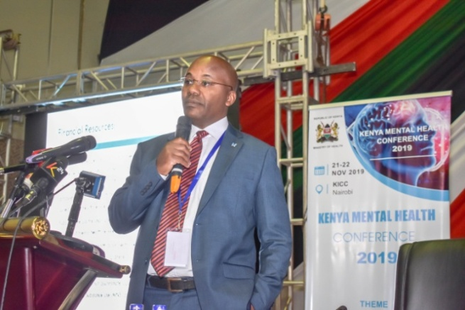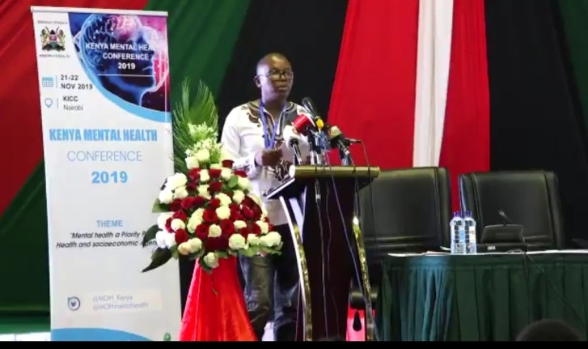
Dr Simon Njuguna, Director Mental Health Michael Njenga, Executive Director Users and Survivors of Psychiatry Kenya

Addresses and messages from the invited guests
The World Health Organization (WHO) Country representative Rudi Eggers noted that the world is accepting the concept of Universal Health Care (UHC) and mental health must be a part of it to ensure access to quality and affordable treatment.“WHO has established the QualityRights initiative, a global initiative to improve the quality of care provided by mental health services and promote human rights of people with psychosocial, intellectual and cognitive disabilities,” said Dr Eggers

The QualityRights initiative will improve quality of care and human rights in inpatient and outpatient mental health services, create community based and recovery oriented mental health and related services that respect and promote human rights. It will also develop a movement of people with mental health conditions and psychosocial disabilities to provide mutual support, conduct advocacy and influence policy making processes as well as reform nation policies and legislation in line with international human rights standards.

The Chairperson on the Parliamentary Health Committee Sabina Chege, who was also present said that part of the money in the supplementary budget will be channeled towards the funding of the mental healthcare facilities. “We need to look at the financing of mental health care, how much is the National Hospital Insurance Fund paying for the services and are there enough facilities and personnel to provide services to people with mental health conditions,” Chege argued. She encouraged Kenyans to talk about the mental health issue and support the persons that openly come out to seek help and refrain from stigmatizing them. She also emphasized the need to ensure that county hospitals integrate mental health services to help reach out to more people who need those services. She also noted that parliament is supporting the review of the current mental health law

The Principal Secretary, Ministry of Health, Susan N. Mochache, revealed that the country is witnessing an unprecedented rate of suicide deaths and increasing burden due to substance use disorders even among children and adolescents. “As a government we need to ensure that each of the level 5 hospitals in the country has a mental treatment section to help reach out more to the people with mental health conditions,” she noted. Mental health is a key component of health which is defined by the World Health Organization as a state of physical, mental and social wellbeing and not mere absence of infirmity. It estimates that about eight hundred thousand people die annually due to suicide which account for a suicide death every 40 seconds. “The situation is compounded by the pervasive culture of denial, silence and stigma that surrounds mental health,” the PS noted at the opening of the conference. She revealed that in Kenya, mental illnesses are a significant cause of morbidity, with an estimated 25 percent of outpatients and up to 40 percent of in-patients suffering from these conditions, noting that Mental health is not just a duty of Government and Ministry of Health but for everyone and raised the need to adopt an all-inclusive, inter-sectoral, multi-stakeholder approach that is critical in addressing the social determinants of mental health.
“Persons with mental illnesses are often stereotyped, feared or shunned by the society. These negative attitudes have prevented many from seeking timely care, and ultimately hindered them from realizing their dreams and achieving their full potential,” she said.
She called upon the County Governments, with technical support from the Ministry of Health to accelerate the integration of mental health services at all levels of the health system, with particular focus on primary health care, community health services, school health programs and promotion of self-care. The PS also urged the stakeholders to scale up research and surveillance on mental health to inform targeted interventions and urged the delegates to raise the priority accorded to mental health and call for efforts to increase parity of resources allocated to it with physical health.

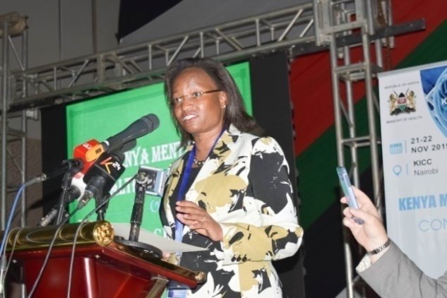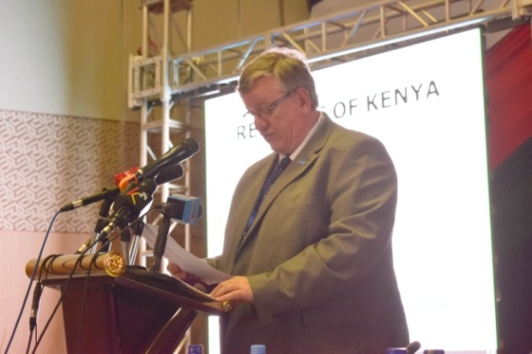
Susan N. Mochache, CBS Dr Rudi Eggers, WHO County
Principal Secretary, Ministry of Health Representative

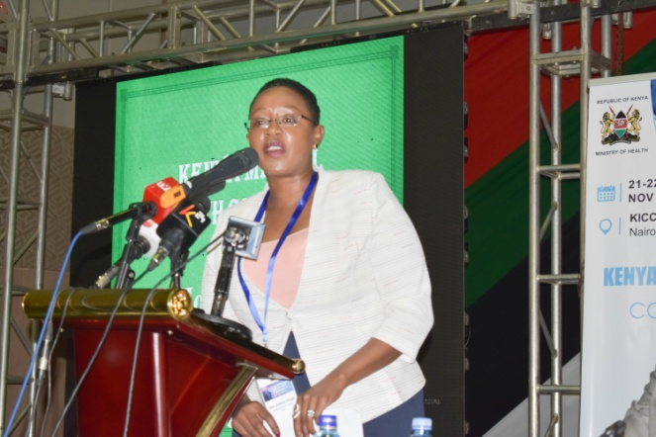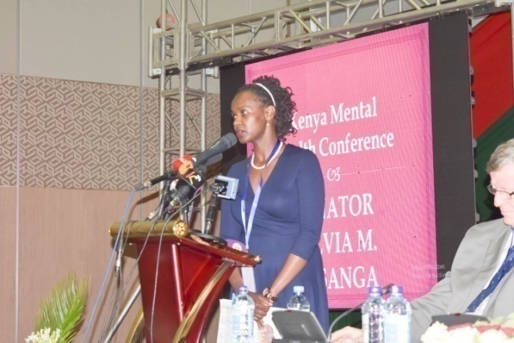
Hon Sabina Chege, Chairperson Parliamentary Senator Sylvia Kasanga,
Health Committee Nominated senator and mental health advocate

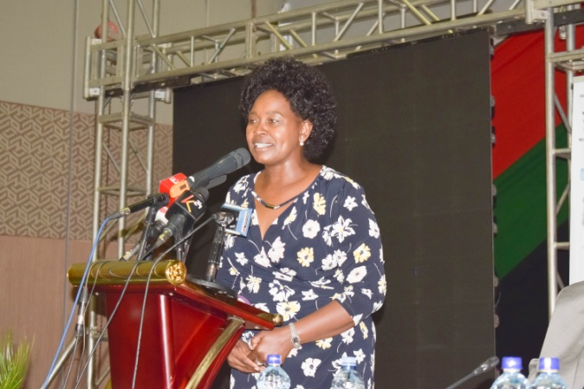
Hon Gladwell Jesire Cheruiyot
Woman Representative, Baringo County

Launch of QualityRights in Mental Health in Kenya
The initiative was launched by the Principal Secretary for Health Susan Mochache. The launch was in form of a video which highlighted the current mental health status in Kenya and how QualityRights initiative aims to transform the narrative. The link to the video: https://qualityrights.org/wp-content/uploads/CompressedQualityRights-Launch-Video-Final.mp4. After the video, all QualityRights champions and those who had undergone the face-to-face training and Assessment training were asked to stand up as the audience applauded. Eddy Kimani, a QualityRights champion then urged everyone to join the movement by enrolling in the QualityRights e-training: http://bit.ly/JoinQRKenya

The guest of honor and the accompanying delegation then proceeded to the Ministry of Health booth where they took photos with the QualityRights twitter and instaframes. The PS, Ministry of Health then signed the QualityRights board committing to promote good quality care and the rights of people with psychosocial, intellectual and cognitive disabilities. We also shared with the invited guests the WHO toolkit.
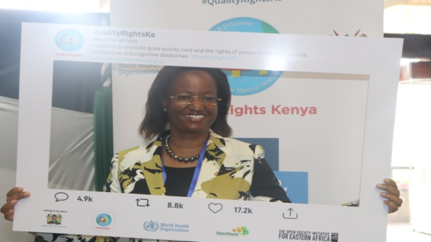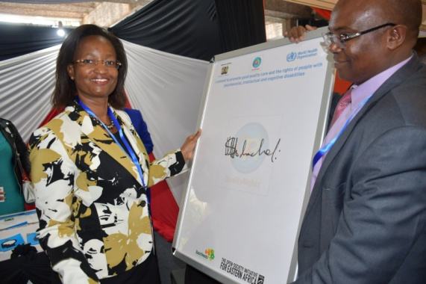
The PS, Ministry of Health, Susan N. Mochache, CBS

2.2: QualityRights panel session
After the launch on the following day during the conference there was a panel session on QualityRights:
Title: Empowering Users’ Organisations and A Human Rights Approach To Care: What’s Critical?
Moderator: Felicia Mburu – Validity Foundation
Panelists:
- Michael Njenga, USP Kenya
- Faiza Sidi, Senior Officer, Research and Compliance Division, Kenya National Commission on Human Rights (KNCHR)
- Elizabeth Mutunga, Alzheimer and Dementia Association of Kenya (ADOK)
- Rosemary Gathara, Basic Needs Basic Rights Kenya
- Nancy Gachoka, Representing Parents & Families

Key points of Panelists Presentation:
The human rights of users of mental health services have to be respected; they should have the right to make decisions concerning their wellbeing as subjects and not objects before the law.
Call for review of the Mental Bill to include the right to vote, the right to hold public office and the right to write a will (property) for persons with mental health disabilities
Treatment to be inclusive and encompassing, to accelerate recovery; capacity building of stakeholders on human rights and mental health; and incorporate transformative justice in human rights in relation to mental health
Normalize human rights and mental health narrative in our society due to their potential for positive outcomes; and build the capacity of caregivers to screen for mental health issues among children and students.
Caregivers to respect the choice users of mental health services have; and treat them with dignity and respect.
Call for respect of boundaries and spaces of persons with mental disabilities; and destigmatization of the same within religious and learning institutions.

Plenary
- Legal amendments in mental health treatment to address the socio-economic and political conditions blighting users of mental health services.
- The normalization of multi-stakeholder engagement in mental health treatment-the establishment of initiatives that tackle mental health challenges connected to issues such as HIV/AIDS.
- Creation of training frameworks that help youth develop effective coping mechanisms in life.
- Developing the most effective means of dealing with mental health challenges facing caregivers- “Who takes care of the caregivers?”
- Increased community engagement and public awareness on mental health treatment and its relation to human rights.
- Informed consent/right of choice should be reinforced in mental health treatment.

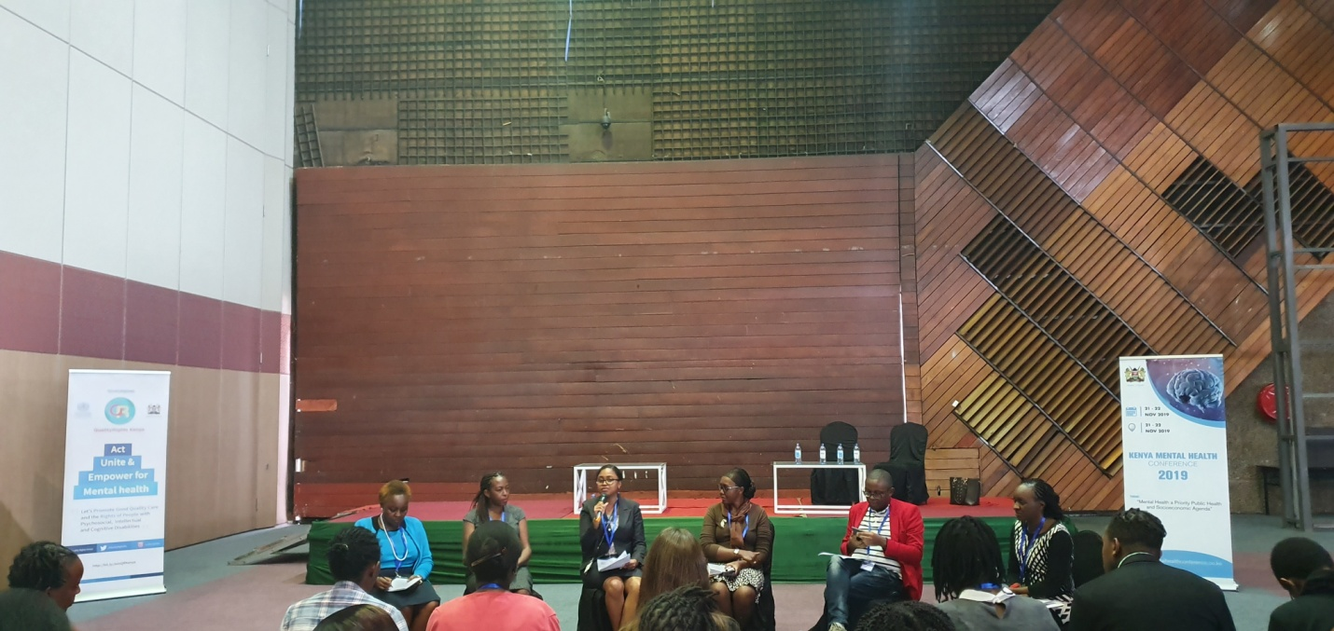
QualityRights session panelists
3.0 Conclusion
At the end of the conference, there were 10 resolutions that were made. Among them was the adaptation of a human rights approach as outlined in the WHO Quality Rights Initiative. Dr Nato made closing remarks applauding the directive from the president on the formation of a mental health taskforce. The official closing speech was given by Dr. Laban Thiga, on behalf of the Director General for Health, Dr. J. Wekesa Masasabi. In the speech, he stated that the QualityRights mental health initiative aims to bring a paradigm shift to the way we talk about mental illness, shed away the negative attitudes, respect, protect and fulfil the rights of persons with lived experience and focus on recovery and community inclusion. He urged everyone to join the QualityRights movement and champion the message of change in our families, communities, workplaces and healthcare services. The mental health services belong to all of us and we must provide services in communities, schools, workplace and health facilities that meet the best standards.
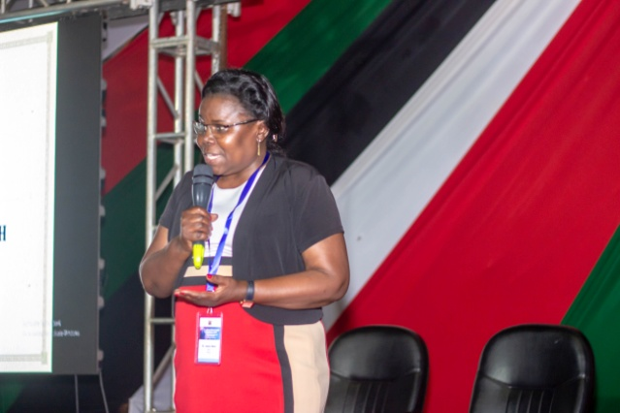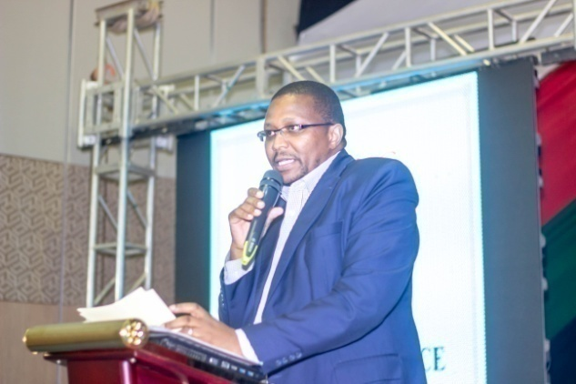
Dr Joyce Nato Dr Laban Thiga
WHO Country Office representative
Annex 1:

SPEECH BY PRINCIPAL SECRETARY FOR HEALTH DURING THE OPENING CEREMONY OF KENYA ANNUAL MENTAL HEALTH CONFERENCE ON 21STNOVEMBER, 2019 AT THE KENYATTA INTERNATIONAL CONVENTION CENTER.
Invited guests,
Ladies and Gentlemen,
Good morning!
I am delighted to join you today in this inaugural Kenya Annual Mental Health Conference 2019. I would like to commend the Ministry of Health and all our stakeholders who have been instrumental to its realization.The conference theme:‘Mental Health as a Public Health and Socioeconomic Agenda’recognises the integral role good mental health and wellbeing plays in achieving the Sustainable Development Goals and is well aligned to the Government's agenda for Universal Health Coverage as well as His Excellency the President’s directive to formulate an appropriate multi-sectorial response to address the increasing trend of suicide, depression and other mental health issues and determinants.
Why should we care about mental health?
Globally, the World health Organisation (WHO) estimate about eight hundred thousand people die annually due to suicide which account for a suicide death every 40 seconds.In Kenya, mental illnesses are a significant cause of morbidity, with an estimated 25% of outpatients and up to 40% of in-patients suffering from these conditions.The country has witnessed an unprecedented rate of suicide death and increasing burden due substance use disorders and related complications, even among children and adolescents is also of concern. Thissituation is compounded by the pervasive culture of denial, silence and stigma that surrounds mental health. Many of us erroneously ascribe mental illness to curses, evil spirits, or witchcraft. Persons with mentalillnessesare often ostracized, stereotyped, feared or shunned by the society.These negative attitudes have prevented many from seeking timely care, and ultimately hindered them from realizing their dreams and achieving their full potential.
Ladies and Gentlemen;

This must change. Failure to address mental health portends significant socio-economic implications in terms of health care-needs and lost productivity and ultimately curtails the achievement of our goals as a country. A lot of gains have made in overall improvement of physical health status of our people; the rising burden of mental ailments however threatens to reverse these gains.This calls for strategic positioning of mental health in the country’s agenda and mobilization of resources to address these disparities.
In today’s fast-paced world and highly competitive job market environment, the work place is increasingly becoming stressful, with demands of high work load, long working hours and even information overload. In these settings, we might feel under pressure, overwhelmed and even suffer burn-out. I urge employers and the relevant government entities to put in place measures to integrate mental health and wellness, including social support systems at the workplace.
Ladies and Gentlemen;
Mental health is a key component of health which is defined by the World Health Organisation as a state of physical, mental and social wellbeing and not mere absence of infirmity. The Constitution of Kenya 2010 established a devolved system of government that largely devolved health service delivery. This has the potential to increase equitable access to mental health services. I urge County Governments, with technical support from the Ministry of Health to accelerate the integration of mental health services at all levels of the health system, with particular focus on primary health care, community health services, school health programs and promotion of self-care. This will go a long way in improving community screening, early identification and referral, psychosocial rehabilitation, re-integration and social inclusion. I acknowledge the efforts to implement the WHO Quality Rights initiative in Kenya as part of reorienting our mental health services by adopting a human-rights based approach. Having this in place will help the country move closer to the realization of the constitutional right to the highest attainable standards of health.

Ladies and Gentlemen;

This conference provides a platform to share knowledge and experiences, and build on the evidence base for mental health programming. I urge all of us to scale up research and surveillance on mental health to inform targeted interventions.
As delegates in this conference, we have been bestowed a historic opportunity to raise the priority accorded to mental health and call for efforts to increase parity of resources allocated to it with physical health.Evidence from cost benefit analysis indicates that for every shilling spent on mental health, five are gained in overall health and economic benefits.

Mental health is not just a duty of Government and Ministry of Health but for us all. There is need to adopt an all-inclusive, inter-sectoral, multi-stakeholder approach that is critical in addressing the social determinants of mental health. The diverse backgrounds and disciplines of the delegates in this conference provides an opportunity to foster strategic partnerships to improve mental health in our country. I encourage more partnerships between local and international organizations including the private sector towards improving access to high quality and affordable mental health services in line with the Universal Health Coverage agenda.

Ladies and Gentlemen;

A healthy country is a productive and prosperous country. As we work towards the attainment of Vision 2030,I call upon wananchi to play a leading role in taking responsibility for their own mental well-being, and to mobilize each other to come forward for assistance. Further, let us all be that person who our family, friends, neighbors or workmates turn to when they need mental health support.

As I conclude;
Today I am happy to witness and recognize the important role played by mental health workers, researchers, advocates, donors and most importantly, persons living with mental health conditions and psychosocial disabilities. Your efforts and time taken to improve the mental health status of our citizens do not go unnoticed. I will continue supporting you as you tirelessly discharge your duties.

Once again, I want to reiterate my commitment to advancing the mental health agenda in Kenya, for there is no health without mental health.
God bless you all
Asanteni

ANNEX 2:

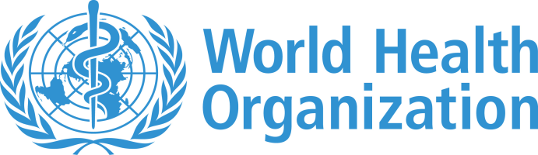

COUNTRY OFFICE IN KENYA

REMARKS DURING THE
KENYA MENTAL HEALTH CONFERENCE

KENYATTA INTERNATIONAL CONVENTION CENTRE. NAIROBI
21st -22nd NOVEMBER 2019.

BY: DR RUDI EGGERS
WHO COUNTRY REPRESENTATIVE, KENYA

The Master of ceremony Dr. John W. Masasabi Director General for Health

The Chief Guest, H.E. Mrs Margaret Kenyatta, First Lady of the Republic of Kenya
Cabinet Secretary for Ministry of Health,Sicily Kariuki (Mrs.) EGH
Honorable Ministers in charge of Health from Burundi, Rwanda, Tanzania, Ethiopia, and Uganda
Principal Secretary of Health Susan N. Mochache
Chief Executive Officer – COGJacqueline Mogeni
Chief Administrative Secretary, HealthDr. Rashid Amani
All Protocol Observed
Ladies and Gentlemen
It gives me great honor to be with you today as we gather here to deliberate on mental health as a priority public health and socio-economic agenda. Health is a state of complete physical, mental and social well-being and not merely the absence of disease or infirmity. An important implication of this definition is that mental health is more than just the absence of mental disorders or disabilities.
Mental health is a state of well-being in which an individual realizes his or her own abilities, can cope with the normal stresses of life, can work productively and is able to contribute to his or her community. Mental health is therefore fundamental to our collective and individual ability as humans to think, emote, interact with each other, earn a living and enjoy life. On this basis, the promotion, protection and restoration of mental health is regarded as a vital concern of individuals, communities and societies throughout the world.
Multiple social, psychological, and biological factors determine the level of mental health of a person at any point of time. Poor mental health is associated with rapid social change, stressful work conditions, gender discrimination, social exclusion, unhealthy lifestyle, physical ill-health and human rights violations.
Good mental health status is therefore a priority by all, not just the health sector.We encourage that national mental health policies should be concerned both with mental disorders and, with broader issues that promote mental health. We also recommend that mental health promotion be mainstreamed into governmental and nongovernmental policies and programmes.
Ladies and Gentlemen,
Despite all of us acknowledging that there is no health without mental health, mental health still remains a neglected part of global efforts to improve health. People with mental health conditions experience widespread human rights violations, discrimination and stigma. More than 80% of people experiencing mental health conditions, including individuals experiencing neurological and substance use disorders, are without any form of quality, affordable mental health care. This is despite mental health conditions accounting for 1 in 5 years lived with disability globally, leading to more than US$ 1 trillion per year in economic losses.
It is well known that people living with mental health conditions are more likely to face other physical health problems such as HIV, TB, non-communicable diseases, causing early mortality of 10-20 years. Suicide mortality is high (close to 800 000 deaths per year), disproportionately affecting young people and elderly women in low- and middle-income countries.
Ladies and Gentlemen,
The world is accepting the concept of universal health coverage and mental health must be an integral part of UHC that ensures access to quality and affordable care for mental health conditions. Cost-effective public health and inter-sectoral strategies and interventions exist to promote, protect and restore mental health. In this regard, WHO has established the QualityRights Initiative, a WHO’s global initiative to improve the quality of care provided by mental health services and promote the human rights of people with psychosocial, intellectual and cognitive disabilities. It offers a new approach to mental health care that is rights-based and recovery oriented.
The QualityRights Initiative has five objectives namely to:
• Improve quality of care and human rights in inpatient and outpatient mental health services;
• Create community based and recovery oriented services that respect and promote human rights;
• Promote human rights, recovery, and independent living in the community;
• Develop a movement of people with mental disabilities to provide mutual support, conduct advocacy and influence policy-making processes; and
• Reform national policies and legislation.
Today the country is officially launching the WHO QualityRights Initiative. Congratulations. Effectively implemented, it will transform the mental health services in this great nation. Remember, there is no health without mental health.
Thank you for your attention

Written by
Director Mental Health – Dr Simon Njuguna
QualityRights Secretariat – Jacqueline Aloo and Joy Muhia

