QualityRights Gujarat
A family member’s perspective
Pratapji Thakor’s Story

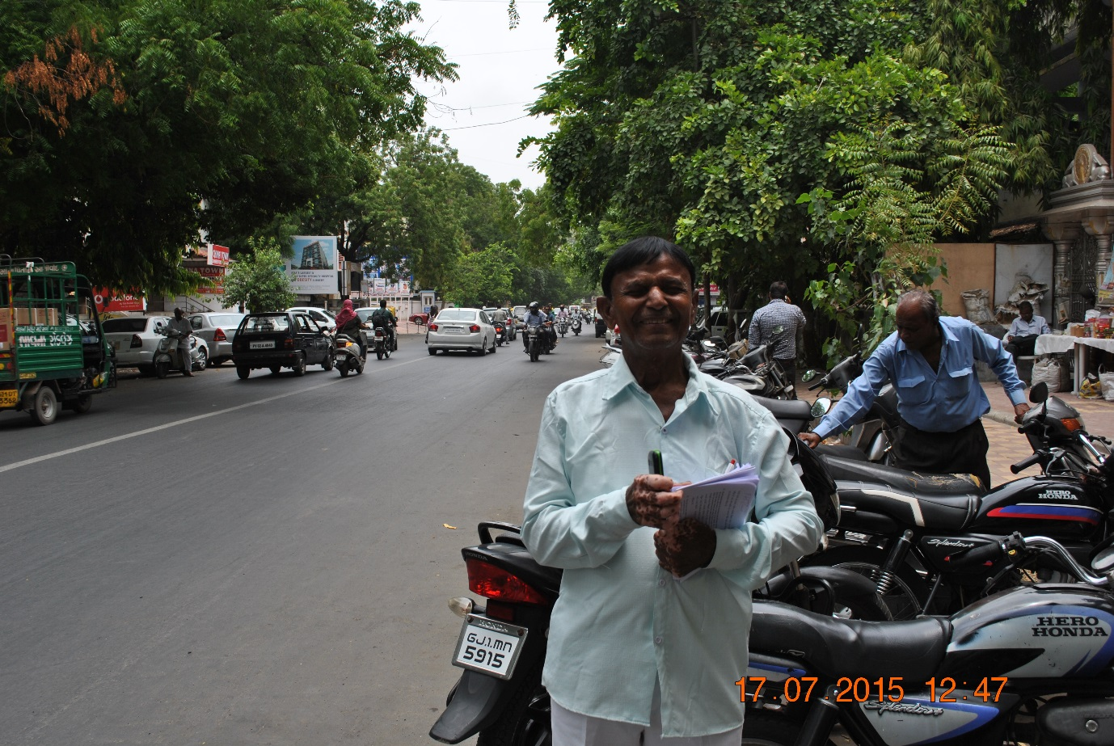

Pratapji Thakor, is a man in his 50’s who lives in Mehsana, Gujarat, with his wife, sons, daughters-in-laws, and grandmother. He has been a carer to his 23-year-old son, Ranjitbhai Thakor, who was diagnosed with schizophrenia five years ago and who also has polio. Since his retirement Mr Thakor runs a small shop which is the primary source of income for the family. Most of his day is spent in taking care of his son.

Prior to his mental health condition, Ranjitbhai Thakor was also running a shop that his father had set up for him. He was married at 18, after which he started to show the first signs of distress. At first the family did not know what to make of the change in Ranjitbhai. “Initially, I thought someone could have done some Jadoo Mantar (magic) on him. He would sit with us and not talk to us”.

The stigma associated with his son’s condition has also impacted on Pratapji Thakor’s interactions with his family and community, as well as the outlook for his future. “Earlier I had a job. I took care of all my children very well. I hoped that they would grow up and take care of me. My life was good. But somehow Ranjitbhai got the illness and that was a source of a lot of tension…. When family members ask what my son is doing, I have to say one of my sons is working and the other is not. My wife feels sad when she has to say this. For me, what can I say, It is my fate. This is what’s written in his fate. We have to bear this difficulty.”
For the past year however, Ranjitbhai has been receiving outpatient treatment at the Psychiatric Department at the General Hospital Mehsana. Pratapji Thakor accompanies his son every month to the hospital, in order to receive mental health care.

For the last several months he has participated in QualityRights training activities being undertaken at the General Hospital, and has also been attending the peer support for family and caregivers - known as “SAATHI” groups - that has been established as part of the project. The group has helped him become better informed about coping with his his son’s condition and has also given him hope concerning his son’s recovery.

“I feel good that there is this project running. The Saathi meetings help me to understand my son’s illness better…. [Ranjitbhai] has gotten better over time. …After coming to the Saathi group I listen to others I have realized that this is MY son, and I have to continue taking care of him. Sometimes others have given me advice of including him in the daily business and this gives me hope that he will be able to do work one day.”
Mr Thakor feels that his relationship with hospital staff, who have also received QualityRights training, has changed over the past year. He has noticed a change in the social environment of the service and feels more supported them. “Earlier I used to come, we didn’t know the staff. We used to come, take the medication and leave. Now everyone has become like family. I know everyone’s names here. And I can ask anyone for anything and they will help me.”
Overall, the training sessions and the peer support groups (SAATHI) have made a significant impact on Pratapji Thakor, giving him hope for Ranjitbhai’s future and a better understanding of how he can support him. Summarising his experience of the QualityRights activities at the hospital, Mr Thakor says, “After attending all this, I have realized that we have to do our best to include {my son} in work and house activities and that I have to keep working for him to help him get better.”

****************
Collaborators on the QualityRights Gujarat project include the Centre for Mental Health Law and Policy ILS Pune, World Health Organization Geneva, CAMH Toronto, Hospital for Mental Health Ahmedabad, Schizophrenia Awareness Association, Pune, SCARF Chennai and Public Health Foundation of India (PHFI) New Delhi.

This Project is supported by Grand Challenges Canada. Grand Challenges Canada is funded by the Government of Canada and is dedicated to supporting Bold Ideas with Big Impact ® in global health.

