Photo Essay
QualityRights: Gujarat
The perspective of people using mental health services
QualityRights Gujarat was launched in July 2014 by the Ministry of Health and Family Welfare in the State of Gujarat. Based on the World Health Organization’s QualityRights initiative and tools, the project has involved a range of interventions including the assessment and improvement of quality and human rights conditions in mental health services throughout the State, capacity building on mental health, human rights, recovery and the UN Convention on the Rights of Persons with Disabilities, the recruitment and training of peer support volunteers within each of the services, and the establishment of peer support groups for both people with psychosocial disabilities and for families and caregivers.

QualityRights Gujarat was funded by Grand Challenges Canada and the Government of Canada. Collaborators on the project include the Centre for Mental Health Law and Policy ILS Pune, World Health Organization Geneva, CAMH Toronto, Hospital for Mental Health Ahmedabad, Schizophrenia Awareness Association, Pune, SCARF Chennai and Public Health Foundation of India (PHFI) New Delhi.

In this photo essay, we document the stories, experiences and perspectives of some of the people with psychosocial disabilities who participated in QualityRights Gujarat.

This Project is supported by Grand Challenges Canada. Grand Challenges Canada is funded by the Government of Canada and is dedicated to supporting Bold Ideas with Big Impact ® in global health.

ESTABLISHING RECOVERY ORIENTED SERVICES
One of the key interventions of QualityRights Gujarat is to support people using the services to create their own recovery plans. A recovery plan is a written document which outlines a person’s own personal choices and preferences in terms of the treatment, care and support they wish to receive. A plan does not just focus on medication but takes into account the person’s personal goals and understanding of what it means to be well. The content of the plan is determined and decided by the person concerned, but can be developed in consultation with families, health care providers, peers and other supporters.
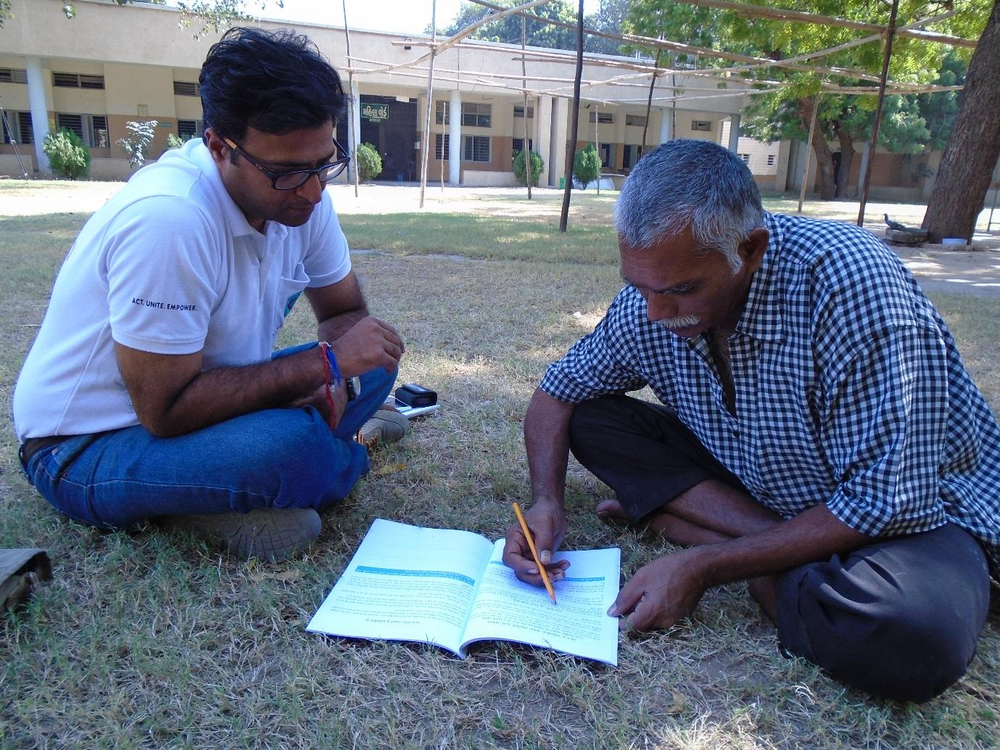
Strengthening relationships through the development of recovery plans
Mr. Jigar Parekh has been actively involved in developing his own recovery plan, which has enabled him to express his views on what helps him in his recovery, and in the process, strengthened an important personal relationship. He explains:
“The plan is helping me to build a stronger relationship with my mother. I cannot recall a time when I last sat with my mother in a long conversation like this and discussed things that will work for me and those that will not. My dreams and aspirations were never a discussion. I feel that if the users also fill these plans with their caregivers, they will get a chance to get close to those they love.”
***************
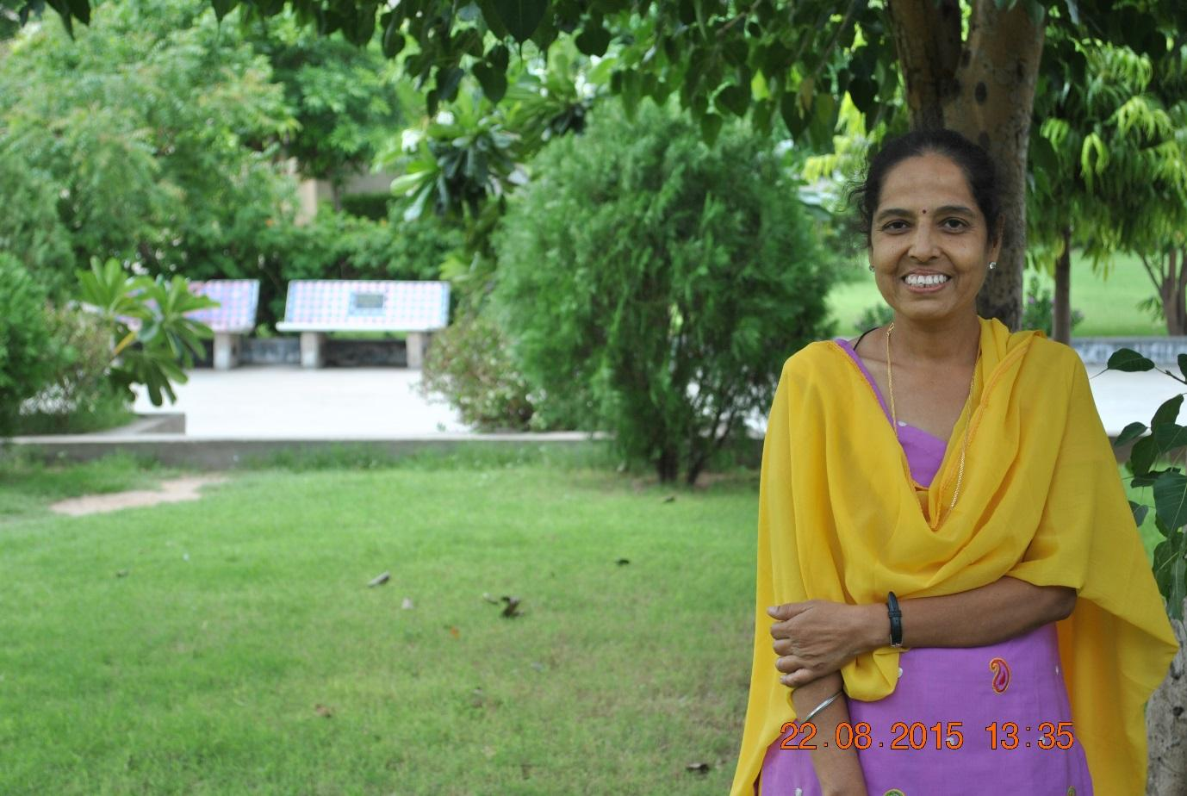
Development of Confidence in the Sense of Improved Personal Agency
Ms. Sunita Bhatia receives metal health services from Hospital for Mental Health Ahmedabad. She too, as part of the QualityRights project, has been encouraged to make a recovery plan to outline her choices and preferences for treatment, care and support. Speaking about her plan she says:
“Making a plan for myself has led me to new explore areas and develop confidence in me.”

***************

PEER SUPPORT VOLUNTEERS
As part of the QualityRights project, Peer Support Volunteers (PSV) have been recruited and trained at each of the facilities. The role of PSVs is to provide support and advice to other people using services. This may involve, for example, supporting people to develop and implement their recovery plans, informing them about their rights, ensuring that their rights are respected, and so on.
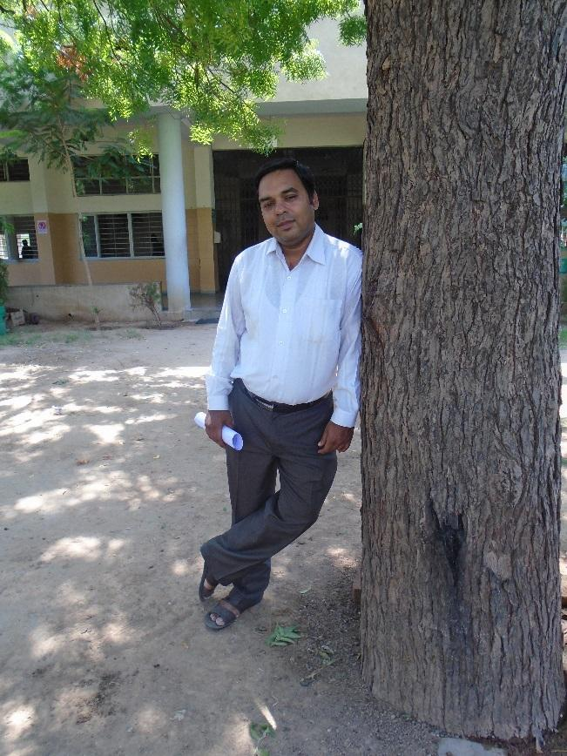

Being supported to move forward

Mr. Chinmay Shah, who is working as a peer support volunteer, has received mentoring from Mr. Vinodh Macwana, who is a staff attendant at the Hospital For Mental Health, Ahmedabad, which has helped him grow and develop his role as a peer support volunteer. He explains:
“I feel a sense of support when I meet Vinodh Bhai. He encourages us to get involved with the users and motivates us to do things effectively without putting pressure on me. We meet him every morning before we start work and he always has a smile to share with us. He also encourages us to approach him whenever we feel the need. The mentoring process is helping us on a daily basis to develop our peer support skills. We improve our work by brain storming and discussing issues with our mentor and we are aware that not only our suggestions are heard but also implemented.”
***************

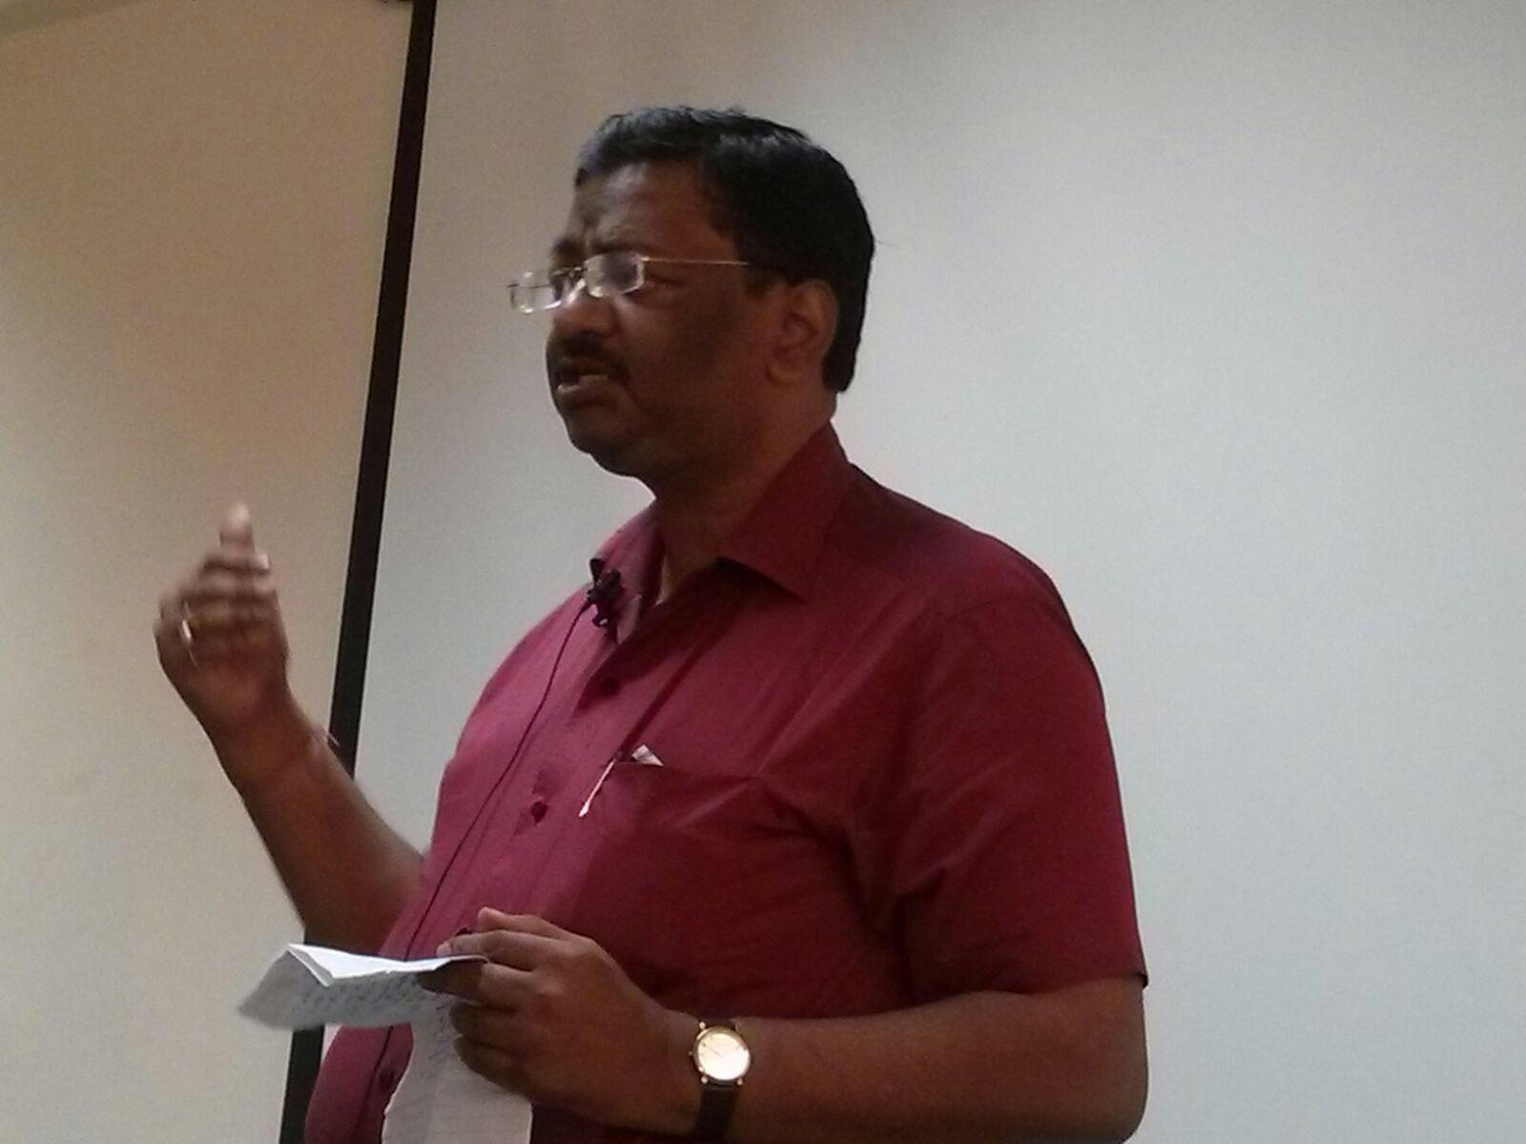

Empowered to speak up and inspire hope in others

Mr. Sanjay Agarwal, who receives mental health services at the New Civil Hospital, Surat, has been actively involved in the QualityRights project and has been working closely with other people using services, to support them in their recovery journey. His involvement has empowered him to use multiple platforms to speak up about his condition, with a view to encouraging others to open up as well. Being a part of the project has brought about a change in the way he understands his own condition as well as that of others.
“Ever since I got involved with the project, I felt that there has been a change in the way I think about mental illness. It has motivated me to help others who may have the same, or more severe problems. I have also learnt to look at patients as individuals beyond their illness, their behaviours, their religion, class or financial status and it has been a very satisfying experience for me.”
***************

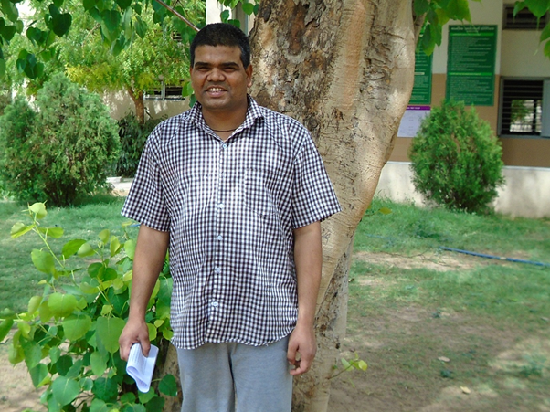

Receiving strength and support from peers
Mr. Nilesh is a gentleman in his 30s who lives in a village near Ahmedabad, Gujarat. He highlights how his situation improved significantly once he started receiving support from his PSV, Mr. Sameer Masuri.
“When I meet Sameer Bhai, he introduced himself as a Peer Support Volunteer to me. He said that he was a service user himself and slowly by his own efforts and the efforts of his family, he has managed to recover. He said that he could help me as a friend and we could work on my difficulties together.”
“When I started filling the recovery plan with Sameer Bhai …I started developing a faith in myself. Now I am optimistic that my illness is just a part of my life and my life should not be restricted to it. There are so many things in life and I am inspired to pursue them… pursue my goals.”
Mr Nilesh says that Mr Sameer, PSV has helped him to develop his communication skills which has helped him articulate his wishes. He discusses his current and future plans with him as well as any problems that he faces in the hospitals. In addition to support from Mr Sameer, Mr Nilesh also receives peer support from the Maitri, a group run by people using services which have been established throughout the state of Gujarat as part of QualityRights. Both types of peer support have given him more confidence to express his needs and strengthen his relationships. He says:
“Since I have started communicating my needs and desire to my peers in the maitri group, I realise that I have been able to open up for new changes and challenges, which earlier I was not. Now I ask for help when I need it. For a long time I continued this process with Sameer Bhai but now I can go and share my needs and feeling with the staff by myself. I also use the recovery plans for the same. Sameer bhai has helped me to develop a better relationship with the staff.”
He goes on:
“Sameer Bhai has been a guiding light which has helped me to feel better about myself and my environment. Now I have become confident. My apprehensions and mistrust towards my health staff and other has been transformed into sharing and trustful relationship with them. I try to help other service users however I can. The process of peer support has developed, hope and trust in me and a skill to negotiate with the staff.”
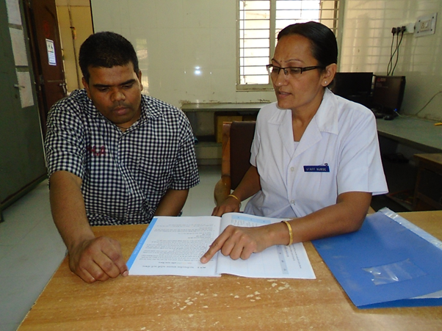
Mr Nilesh discussing the changes he would like to make in his recovery plans with the staff
Talking about what recovery means to him, Mr Nilesh explains: “Making goals and moving ahead to achieve them with a hope to end up somewhere better, is recovery. Little steps count. The ultimate goal for me is to stay with my family and friends and work.”
Mr Nilesh also shares his understanding of human rights. He explains: “The Maitri group has motivated me to understand my right to stay in the community. Also I have become assertive to demand what I need as I consider it as a right to have it.”
***************
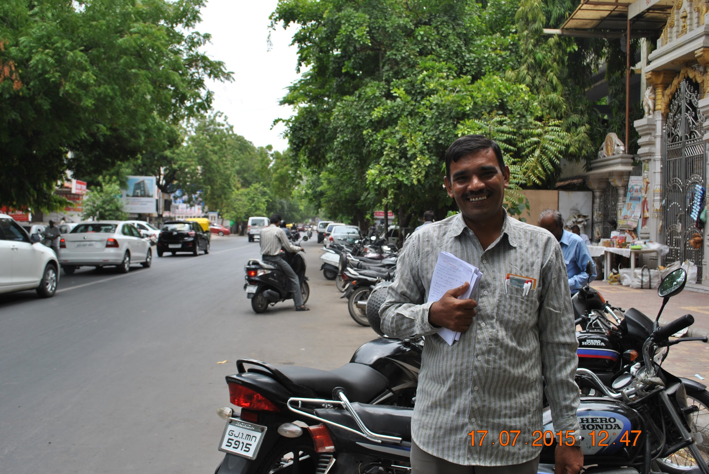

Taking charge and gaining independence
Since the start of the QualityRights Initiative, Mr Piyushbhai Patel has taken an active role in his own recovery and has also been supporting his peers in their recovery journey. He explains the importance of the peer support groups:
“ I have been actively participating in MAITRI groups (peer support groups). Through this group I have been able to learn many new things. In one of the groups a lady spoke about small scale savings. After listening to her I have started a small postal account for myself. I save this money so that I can help my daughter get a good education. One day I hope to see her become a doctor.”
Mr. Patel explains that they also discuss recovery issues in the Maitri group. One recovery principle that has particularly stuck with him is the importance of taking risks and also not being afraid to fail:
“One of the tools I remember very often is - Try fail…try fail…try fail …try succeed”. I was not able to complete my education during my masters due to my illness. But now I feel that I can try.”
Training on human rights has also been important to him, enabling him to speak more openly about his condition:
“I was able to learn a lot of new things due to the QualityRights Human rights trainings. Initially, it was only my wife and my doctor who knew about the illness. After the trainings I was able to tell more people. Now I talk to other service users about my illness and offer hope to them so that they can recover from their illness.”
Mr. Patel highlights other positive factors which have been central to his recovery journey:
“Working on a regular basis makes me happy. When I work I started taking in other things as well, such as doing my own bank work. I start taking decisions that I was unable to do myself. I now escort my daughter on a train to the college that she studies in. I try to keep myself involved in daily activities. I try to exercise regularly to keep myself healthy. I have had the opportunity to make many friends at this hospital. As a father I am proud that I can contribute to the fees for my child education now. Coming to the hospital and being involved in regular activities helps me stay healthy.”
***************

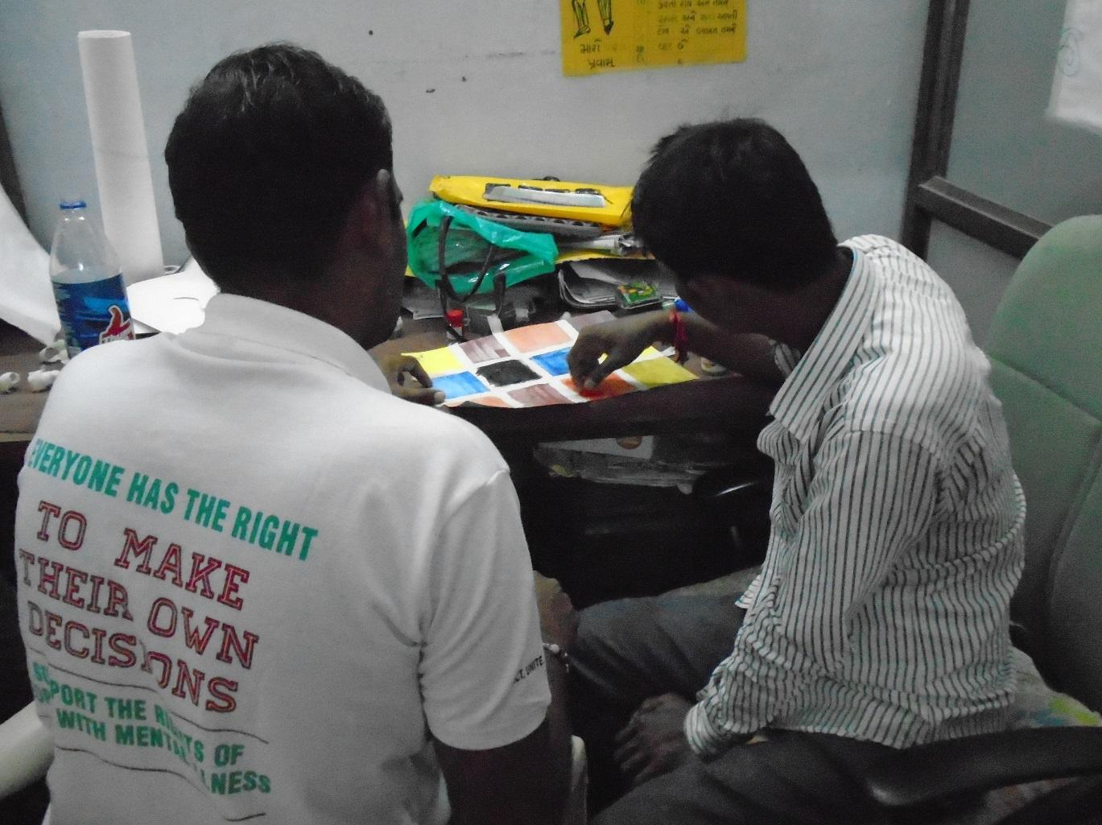

The importance of listening
Rameshbhai (name changed) has been living with a severe mental health condition for the past few years. He has been living with his parents and has had very limited engagement with others and his daily activities. Our Peer Support Volunteers talked with him about his preferences.
“I love painting and drawing”
During the next visit the Peer Support Volunteers’ spent time with him painting and exploring his other interests. A Peer Support Volunteer speaks about his experience in doing the activity.
“Everyone likes to do something or other. We just have to listen, try and find out what it is.”

***************

MAITRI – PEER SUPPORT GROUPS LED BY PEOPLE USING SERVICES
As part of QualityRights Gujarat, peer support groups led by and for people using mental health services have been established throughout the State. These groups - known as ‘Maitri’, or ‘friend’ – enable people to receive and provide mutual emotional and practical support, share experiences and knowledge about recovery and other issues, as well as information about useful resources, services and supports that are available in the community that can be drawn upon.

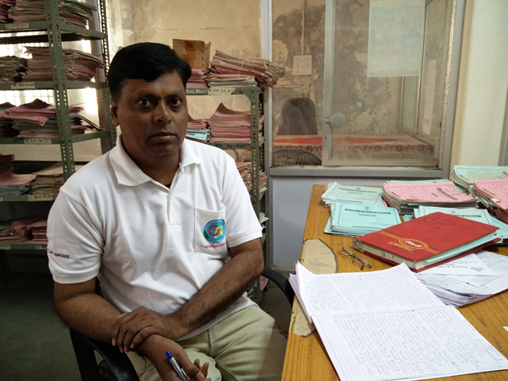

Gaining respect and confidence through participating in peer support groups

Mr. Sawan Rathore, a peer support volunteer Hospital for Mental Health in Bhuj, explains the importance of the Maitri group meetings.
“In the maitri meetings, I get so much respect. Last month I attended a combined meeting for patients and their relatives. Everyone clapped for me because they were surprised that a patient like me can work at the hospital too. I felt very encouraged… I also felt that I am important in some way, for the hospital. At the end of the meeting, people actually came and asked me what I have done for myself to become better…”
***************

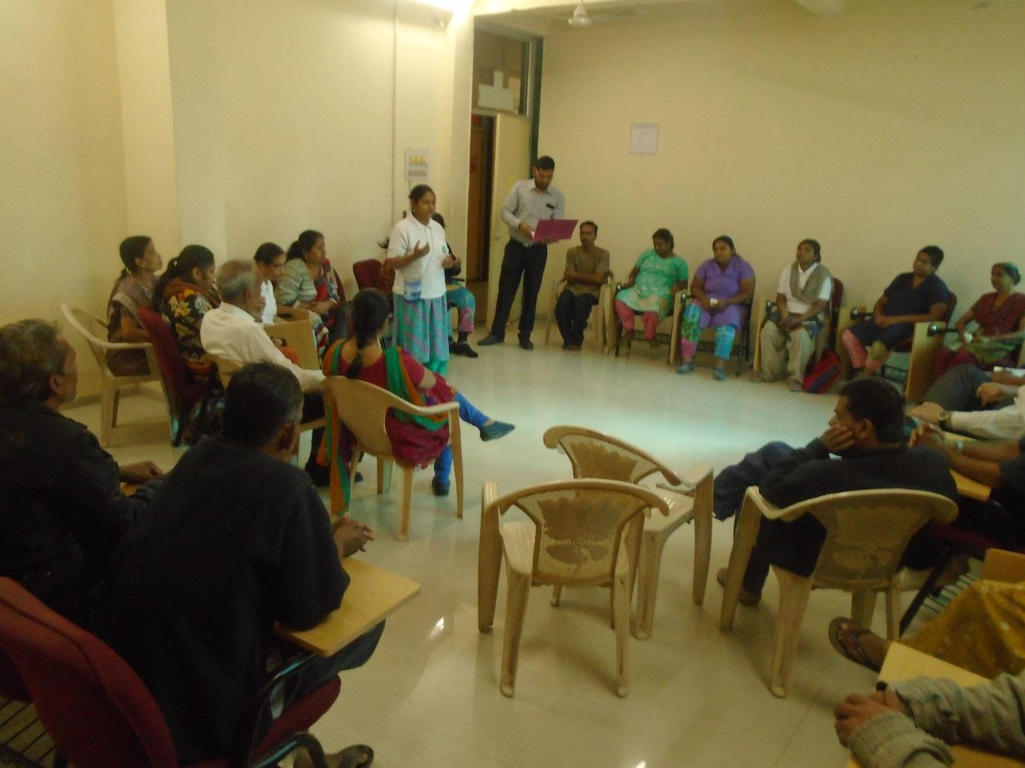

Maitri meetings – a place to share wellness and recovery strategies

Maitri group meetings are a space where people talk about their own recovery and discuss strategies for self-care. Janaki Patel, a Peer Support Volunteer at the Hospital for Mental Health, Vadodara, has also been trained as an anchor person for the Maitri Group meetings. “Anger management” was the topic of discussion for one of the meetings. Ms Patel shared her experience of using rhythmic breathing to help her calm down in times of distress, and manage her anger. In the meeting she demonstrated how she does this and encouraged others to try this for themselves.
***************

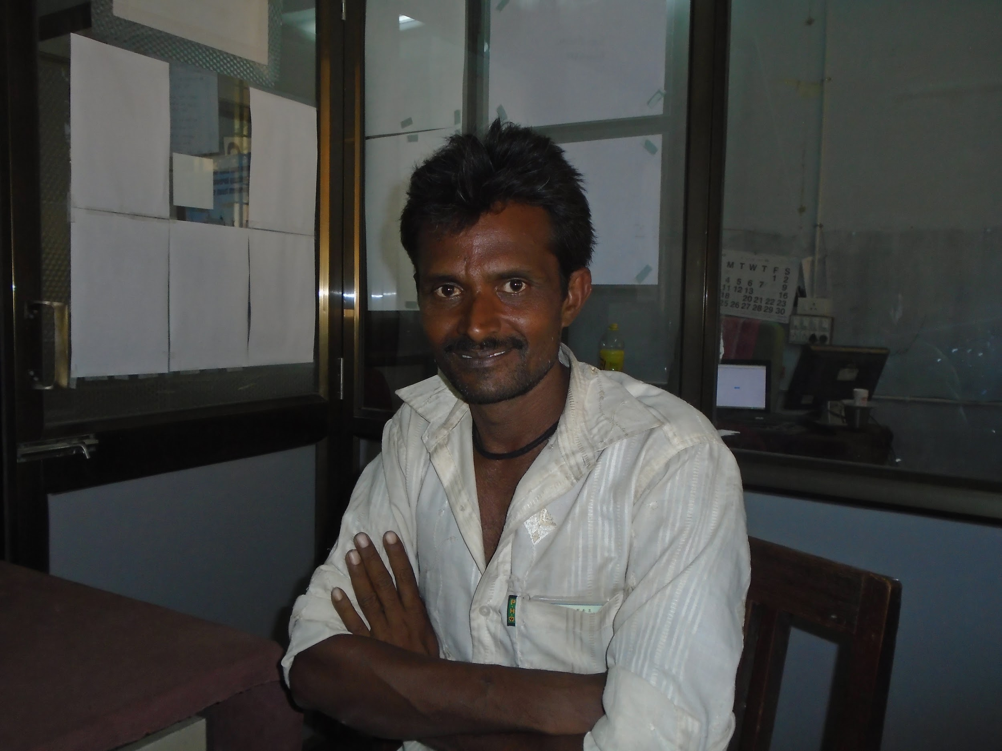

A sense of belonging

Channaji Thakor, who receives mental health services at the General Hospital in Mehsana, has been a member of the peer support group, established as part of QualityRights Gujarat, for several months now. The group has played an important part in providing him with a sense of belonging. He explains:
“When I come for these meetings I feel happy because it make me feel like I belong to some place and that I have someone to support me. I have learnt that there are so many other people like me.”

***************

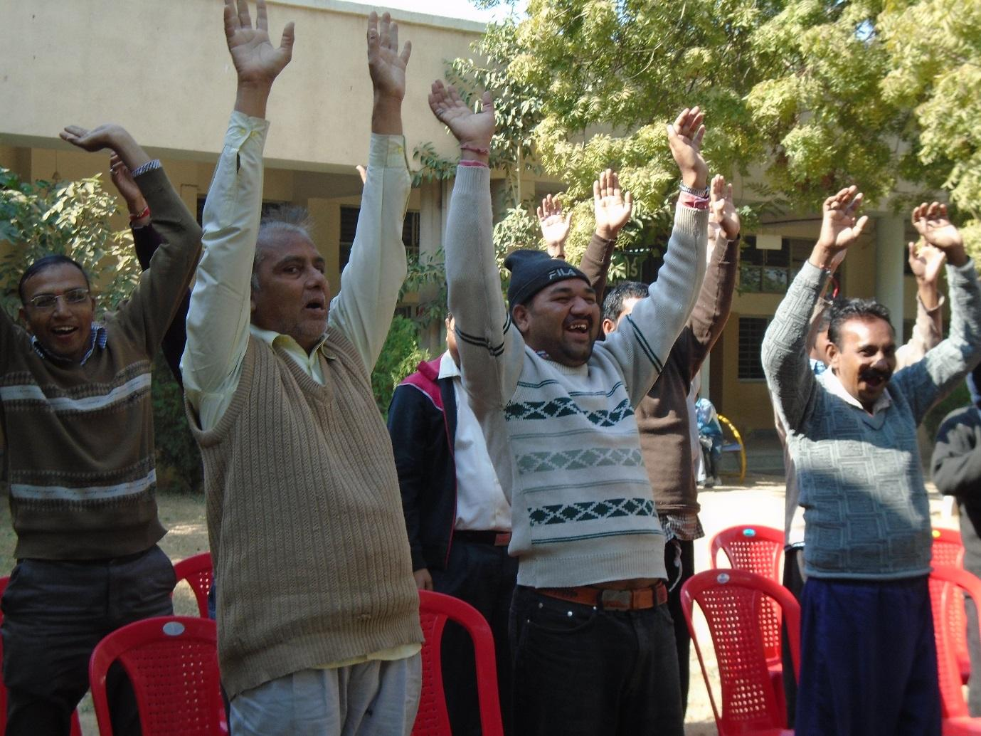
Maitri groups – from ideas to action
The Members of the Maitri group based in Ahmedabad meet ever Saturday at the Hospital for Mental Health. Every meeting they discuss different issues that concern them. Not only are the meetings a time to share problems but also a time to laugh and sing together. One of the participant shared:
“I wait for these meeting as they are a time when I can say what I want and I am not being monitored or judged. I have a good time in this 1 hour.”
Some of the meeting discussions have led to actions. For example, one initiative involved making a library and the gym more accessible for people using inpatient services at the hospital. One of the members addressing the issue said;
“They say that there is a library and a gym in the hospital. If I cannot access it, it’s useless for me.”
Another member residing in one of the wards noted:
“We get bored by sitting in the wards. There is no engagement inside.”
By the end of the meeting, a member of the group had drafted a letter requesting the use of gym and library for all people using the services, which was signed by all members of Maitri.
In addition, a book donation drive was organised, led by PSVs at the hospital. Invitation letters to contribute to the drive were sent to NGOs, staff and caregivers. The drive was a great success, and those who donated books were each given badges with slogans such as “Supporting the rights of persons with mental illness,” as a token of appreciation.
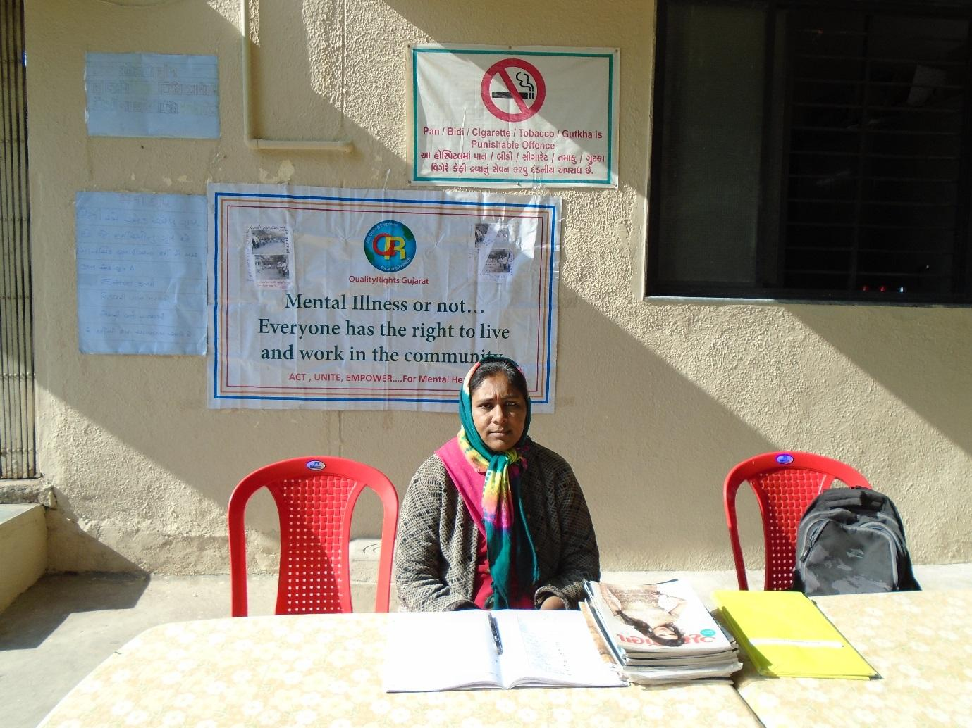
Ms. Sumitra Ben Jaynti Bhai Patel, doing the collection of magazine and books in the book donation drive
The book drive was also seen as an opportunity to raise awareness on the existence of the Maitri group among other people using services. Posters were therefore put up, encouraging people to join the group.

Funding for this work was provided by Grand Challenges Canada and the Government of Canada. Grand Challenges Canada is funded by the Government of Canada and is dedicated to supporting Bold Ideas with Big Impact in global health.

