QualityRights Gujarat
The perspective of a Peer Support Volunteer
Janaki Patel’s story
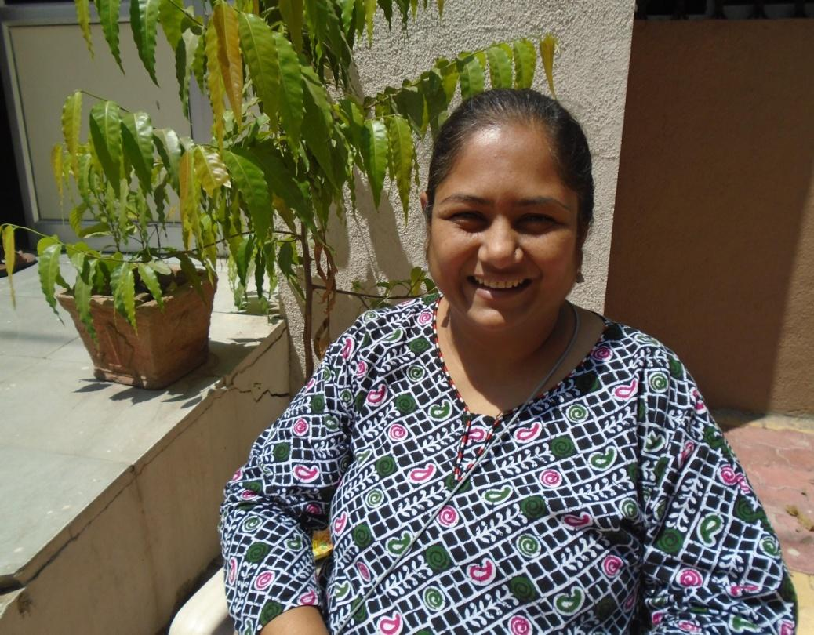

Janaki Patel is a woman in her thirties from Vadodara in Gujarat. She has been an active collaborator in the QualityRights project and is currently employed as a Peer Support Volunteer.
Ever since she was diagnosed with schizophrenia a decade ago, she has been using the outpatient services at the Hospital for Mental Health, Vadodara (HMHV). She first showed signs and symptoms of schizophrenia while she was in 12th grade. “It was during 12th grade that I could not write, could not remember and concentrate. I was at home for 1-2 years and did not see a doctor for the illness then.” Ms Patel suggests that the death of her sister, whom she was very close to, may have triggered her illness, “That came as quite a shock to me as my sister died along with her baby.”
Ms Patel was taken to a psychiatrist in Vadodara a year and a half later, after her condition deteriorated. “We changed a lot of doctors and I have taken so many medications and injections to date that I am fed up now.”
She was admitted to HMHV for two months. At that time, all she wanted to do was to go home. “I felt like I was in jail. I could not see anything outside because of the surrounding walls and I was forced to be here….. The patients were drowsy or could not comprehend anything that was said … I feel sad for service users who have been here for more than 10 years now, which is not a short period .They told me that they go home when they feel better and come back when the situation worsens which is approximately after every 2-3 months. They don’t have the freedom or aren’t given any choices and are mistreated by family.”
As part of QualityRights Gujarat, assessments were undertaken at each of the facilities using the WHO QualityRights Assessment tools and methodology, in order to identify gaps and problems within the services that need to be addressed. The assessments, which were undertaken by committees made up of people with psychosocial disabilities, mental health staff and families, focused among other things on the improvements needed to the physical and social environment of the services.
Ms Patel feels that the overall quality of services in the facility have improved since the project began, including the quality of the food, the cleanliness of the facilities but also importantly in terms of the communication and availability of staff. “When I visit the ward, I can observe a change in the attitudes of the staff nurses” she notes.
The QualityRights recovery training she and others using the service have received has empowered them to become experts in their own care. In addition, as part of QualityRights, Ms Patel has been trained as a Peer Support Volunteer, which has also contributed to her sense of empowerment. She explains “The training helped me understand more about the concept of Recovery…Working as a PSV, I feel empowered that I can help others too”.
In her role as PSV, Ms Patel helps people understand their rights and also supports them in their recovery journey, by working alongside them when they develop recovery plans. “[One] service user shared her story with me which helped her feel better. I explained to her how voicing out her feelings will help. I have had 2-3 sittings with the service user, and I have seen a gradual change in the way the service user communicates with me. I felt an increased amount of confidence within me too.”
Her role as PSV, while fulfilling, is not without challenges although this has also enabled her to learn and to grow. She remarks, “I learned how to remain active, connect to the community and help others connect too. Explaining these concepts to the service users and working with them is quite a task but I am learning.”
Ms Patel also feels a sense of accomplishment thanks to the money she has earned as a peer support volunteer. She added, “Who wishes to sit at home? I feel I should succeed, be able to contribute something meaningful to the society.”
Janaki Patel is pleased with what QualityRights Gujarat has achieved so far, but thinks that more needs to be done. For example, she believes it is important to organise more activities for people using the inpatient services, as she sees this as fundamental to the recovery journey. Also essential, in her opinion, is improving linkages to community services and resources, in order to support people to find jobs and feel more accepted in society, which in turn will open up a whole range of new opportunities in their lives.
********************
Collaborators on the QualityRights Gujarat project include the Centre for Mental Health Law and Policy ILS Pune, World Health Organization Geneva, CAMH Toronto, Hospital for Mental Health Ahmedabad, Schizophrenia Awareness Association, Pune, SCARF Chennai and Public Health Foundation of India (PHFI) New Delhi.

This Project is supported by Grand Challenges Canada. Grand Challenges Canada is funded by the Government of Canada and is dedicated to supporting Bold Ideas with Big Impact ® in global health.

