Photo Essay
QualityRights: Gujarat
The perspective of people providing mental health services
QualityRights Gujarat was launched in July 2014 by the Ministry of Health and Family Welfare in the State of Gujarat. Based on the World Health Organization’s QualityRights initiative and tools, the project has involved a range of interventions including the assessment and improvement of quality and human rights conditions in mental health services throughout the State, capacity building on mental health, human rights, recovery and the UN Convention on the Rights of Persons with Disabilities, the recruitment and training of peer support volunteers within each of the services, and the establishment of peer support groups for both people with psychosocial disabilities and for families and caregivers.

QualityRights Gujarat was funded by Grand Challenges Canada and the Government of Canada. Collaborators on the project include the Centre for Mental Health Law and Policy ILS Pune, World Health Organization Geneva, CAMH Toronto, Hospital for Mental Health Ahmedabad, Schizophrenia Awareness Association, Pune, SCARF Chennai and Public Health Foundation of India (PHFI) New Delhi.

In this photo essay, we document the stories, experiences and perspectives of some of the professionals and staff working in the services who participated in QualityRights Gujarat.

This Project is supported by Grand Challenges Canada. Grand Challenges Canada is funded by the Government of Canada and is dedicated to supporting Bold Ideas with Big Impact ® in global health.

TRAINING ON HUMAN RIGHTS, RECOVERY & THE UN CRPD
One of the major interventions of QualityRights Gujarat involved the widescale delivery of a comprehensive training programme on mental health and human rights and the UN CRPD and on providing recovery oriented mental health care. A number of staff members were trained in each of these areas in order to become QualityRights master trainers able to train other staff at each of the facilities.

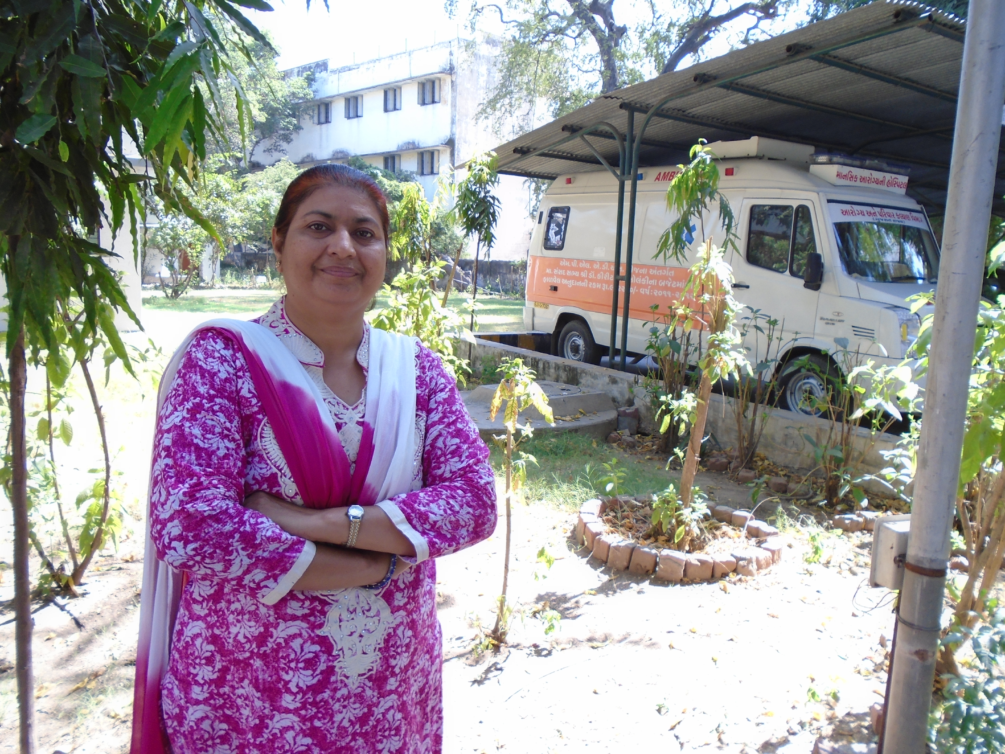

Human rights training - creating a sense of possibility

Dr Nazima Sheikh, a medical officer at the Hospital for Mental Health in Ahmedabad, is today a master trainer on mental health and human rights. Reflecting on her training, she highlights the shift in her beliefs about the rights of people with psychosocial disabilities. She says:
“I believed mental health and human rights to be unrelated concepts. According to me were not concepts related to the facility. The training helped me to work through my biases. I have started believing that rights of persons with mental illness can be respected, protected and fulfilled with a little support.
Earlier right to liberty for persons with mental illness was an alien concept. Now when I see the same service users that I used to see before the training, I see them with a hope and possibility that their rights can be fulfilled. My ideology has shifted from the impossible to IT IS POSSIBLE.”
Having mental health service providers who understand and respect the rights of service users is central to providing good quality mental health services.
*****************

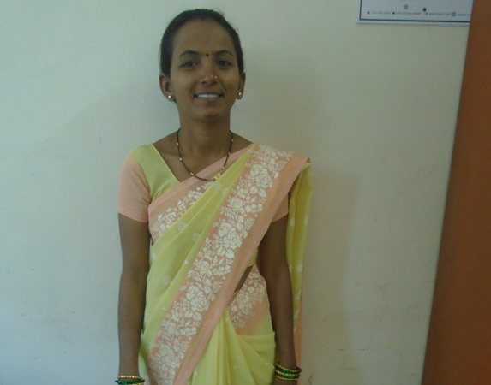

Building leaders that support the rights of people with psychosocial disabilities

Chaya Salekar is an attendant at the Hospital for Mental Health Vadodara and has also become a master trainer on mental health and human rights. She explains that the training has not only shifted her attitude and understanding about the rights of people with psychosocial disabilities, but has also changed her day to day practice and interaction with people using the service.
“I have been trained as a Master trainer for Human Rights. This is the first time in my life that I have conducted a training. I can now conduct trainings confidently. This was not the case when I initially began. The knowledge of rights and learning of new concepts has improved my understanding and attitude to a great extent. This progress has also improved my interaction with the service users. The important aspect of the training is it empowers the service users, staff members and caregivers in what they can do to protect their rights.”
*****************

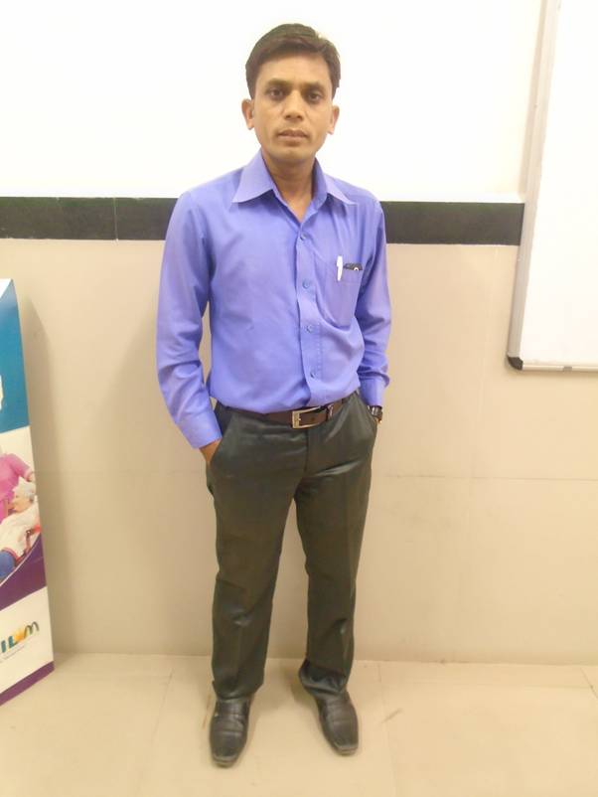

Improving knowledge and skills in order to provide recovery oriented care and support

Atul Solanki is a Social worker at GMERS, Gotri, and has been involved in the QualityRights Gujarat project since its inception. He has been trained as a Master trainer on mental health and human rights and on Communication Skills. He has also received training on how to promote a recovery approach in mental health services. Of the knowledge he has gained in this area he says:
“My association with the QualityRights project has enhanced my knowledge and has improved my skills as a Social worker. I have been trained in recovery, I understand its components better. I feel the recovery plan is a novel concept introduced by the project. It will definitely help the service users. It has brought about a change in the work I have been doing.
I now take conscious efforts of asking open ended questions while working with service users…Before QualityRights intervention I feel I had 20% knowledge of working in the field of mental health but now, after being associated with the project, I feel it has improved by 80% and I credit the project entirely for the same. This has had an impact on me as I feel more confident and well-informed while working within the department and it has also helped improve interpersonal relations.”
*****************

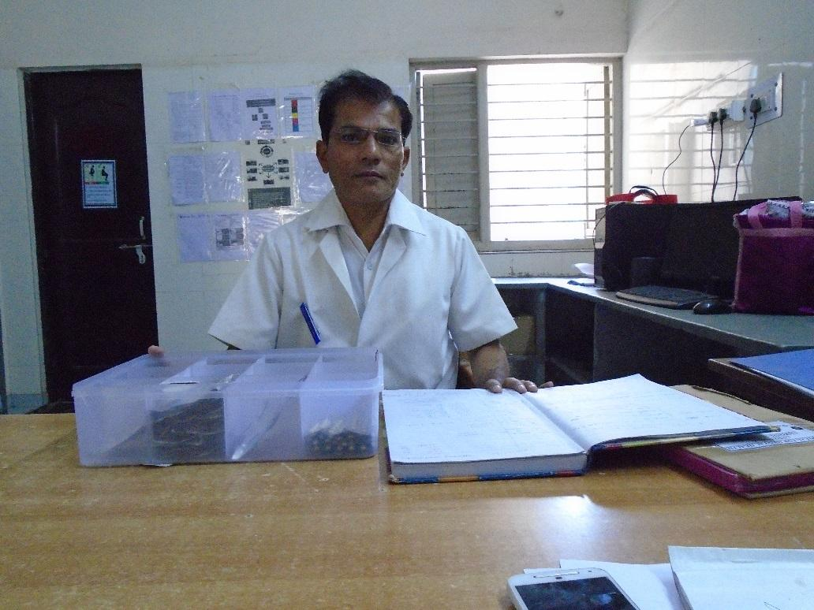

Everyone has the right to be listened to

Mr. Ashwin Patel, Staff Nurse at the Hospital for Mental Health, Ahmedabad, is a Master Trainer in Recovery Oriented Mental Health care. His experience as a master trainer has highlighted for him the importance of listening to people using the services.
“After training the staff, I have come to realise that attention to provide care needs to be given equally to all service users while providing care. In fact the service users who are not very vocal and whose recovery is slow should be given more attention .Earlier service users who were better than the others were given more attention.”
*****************

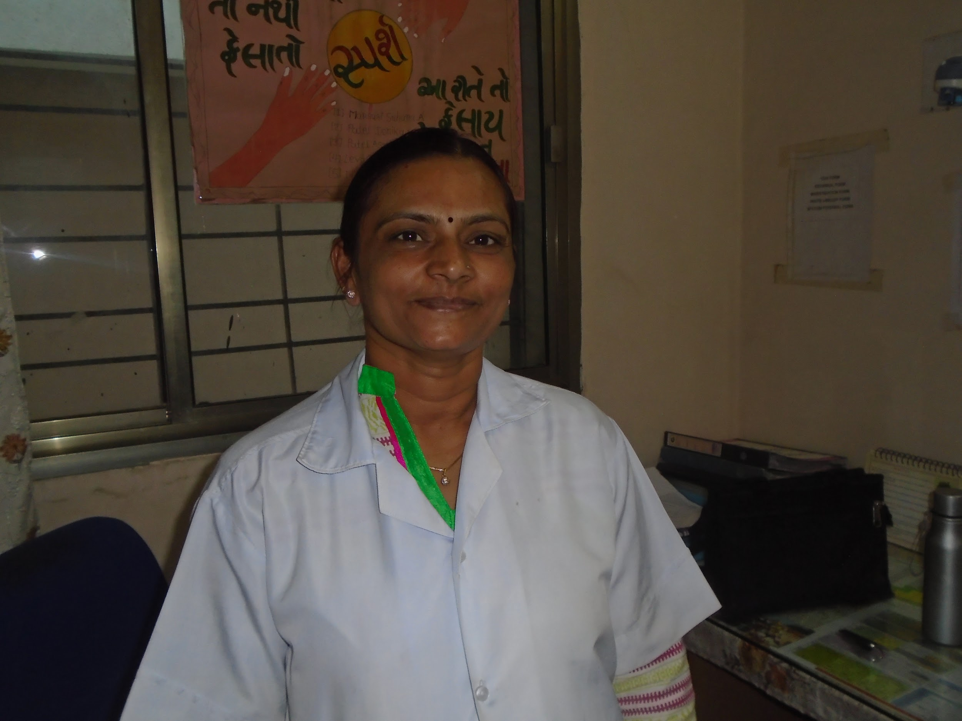

Changing mindsets, changing practices

Jagruti Chauhan is a nurse that works in a General health facility in Mehsana. She feels that the training programmes have changed the way she and her colleagues see people with psychosocial disabilities, which, in turn, has brought about a change in practices at the general hospital, including increased respect for people using the services.
“ I think the most important thing I have learnt through all these trainings is to stop labelling patients. I have seen this change in the wards as well. Earlier when a mentally ill patient was admitted to the general wards, the staff used to refer to them as ‘that Pagal (crazy patient)’. Now we have stopped using these words. We even make sure that the attendants don't use these word. We tell them to refer to them by their name. I feel that we need to give more attention to patients with mental illness and treat them humanely and not neglect them when they come to our hospital.”
*****************

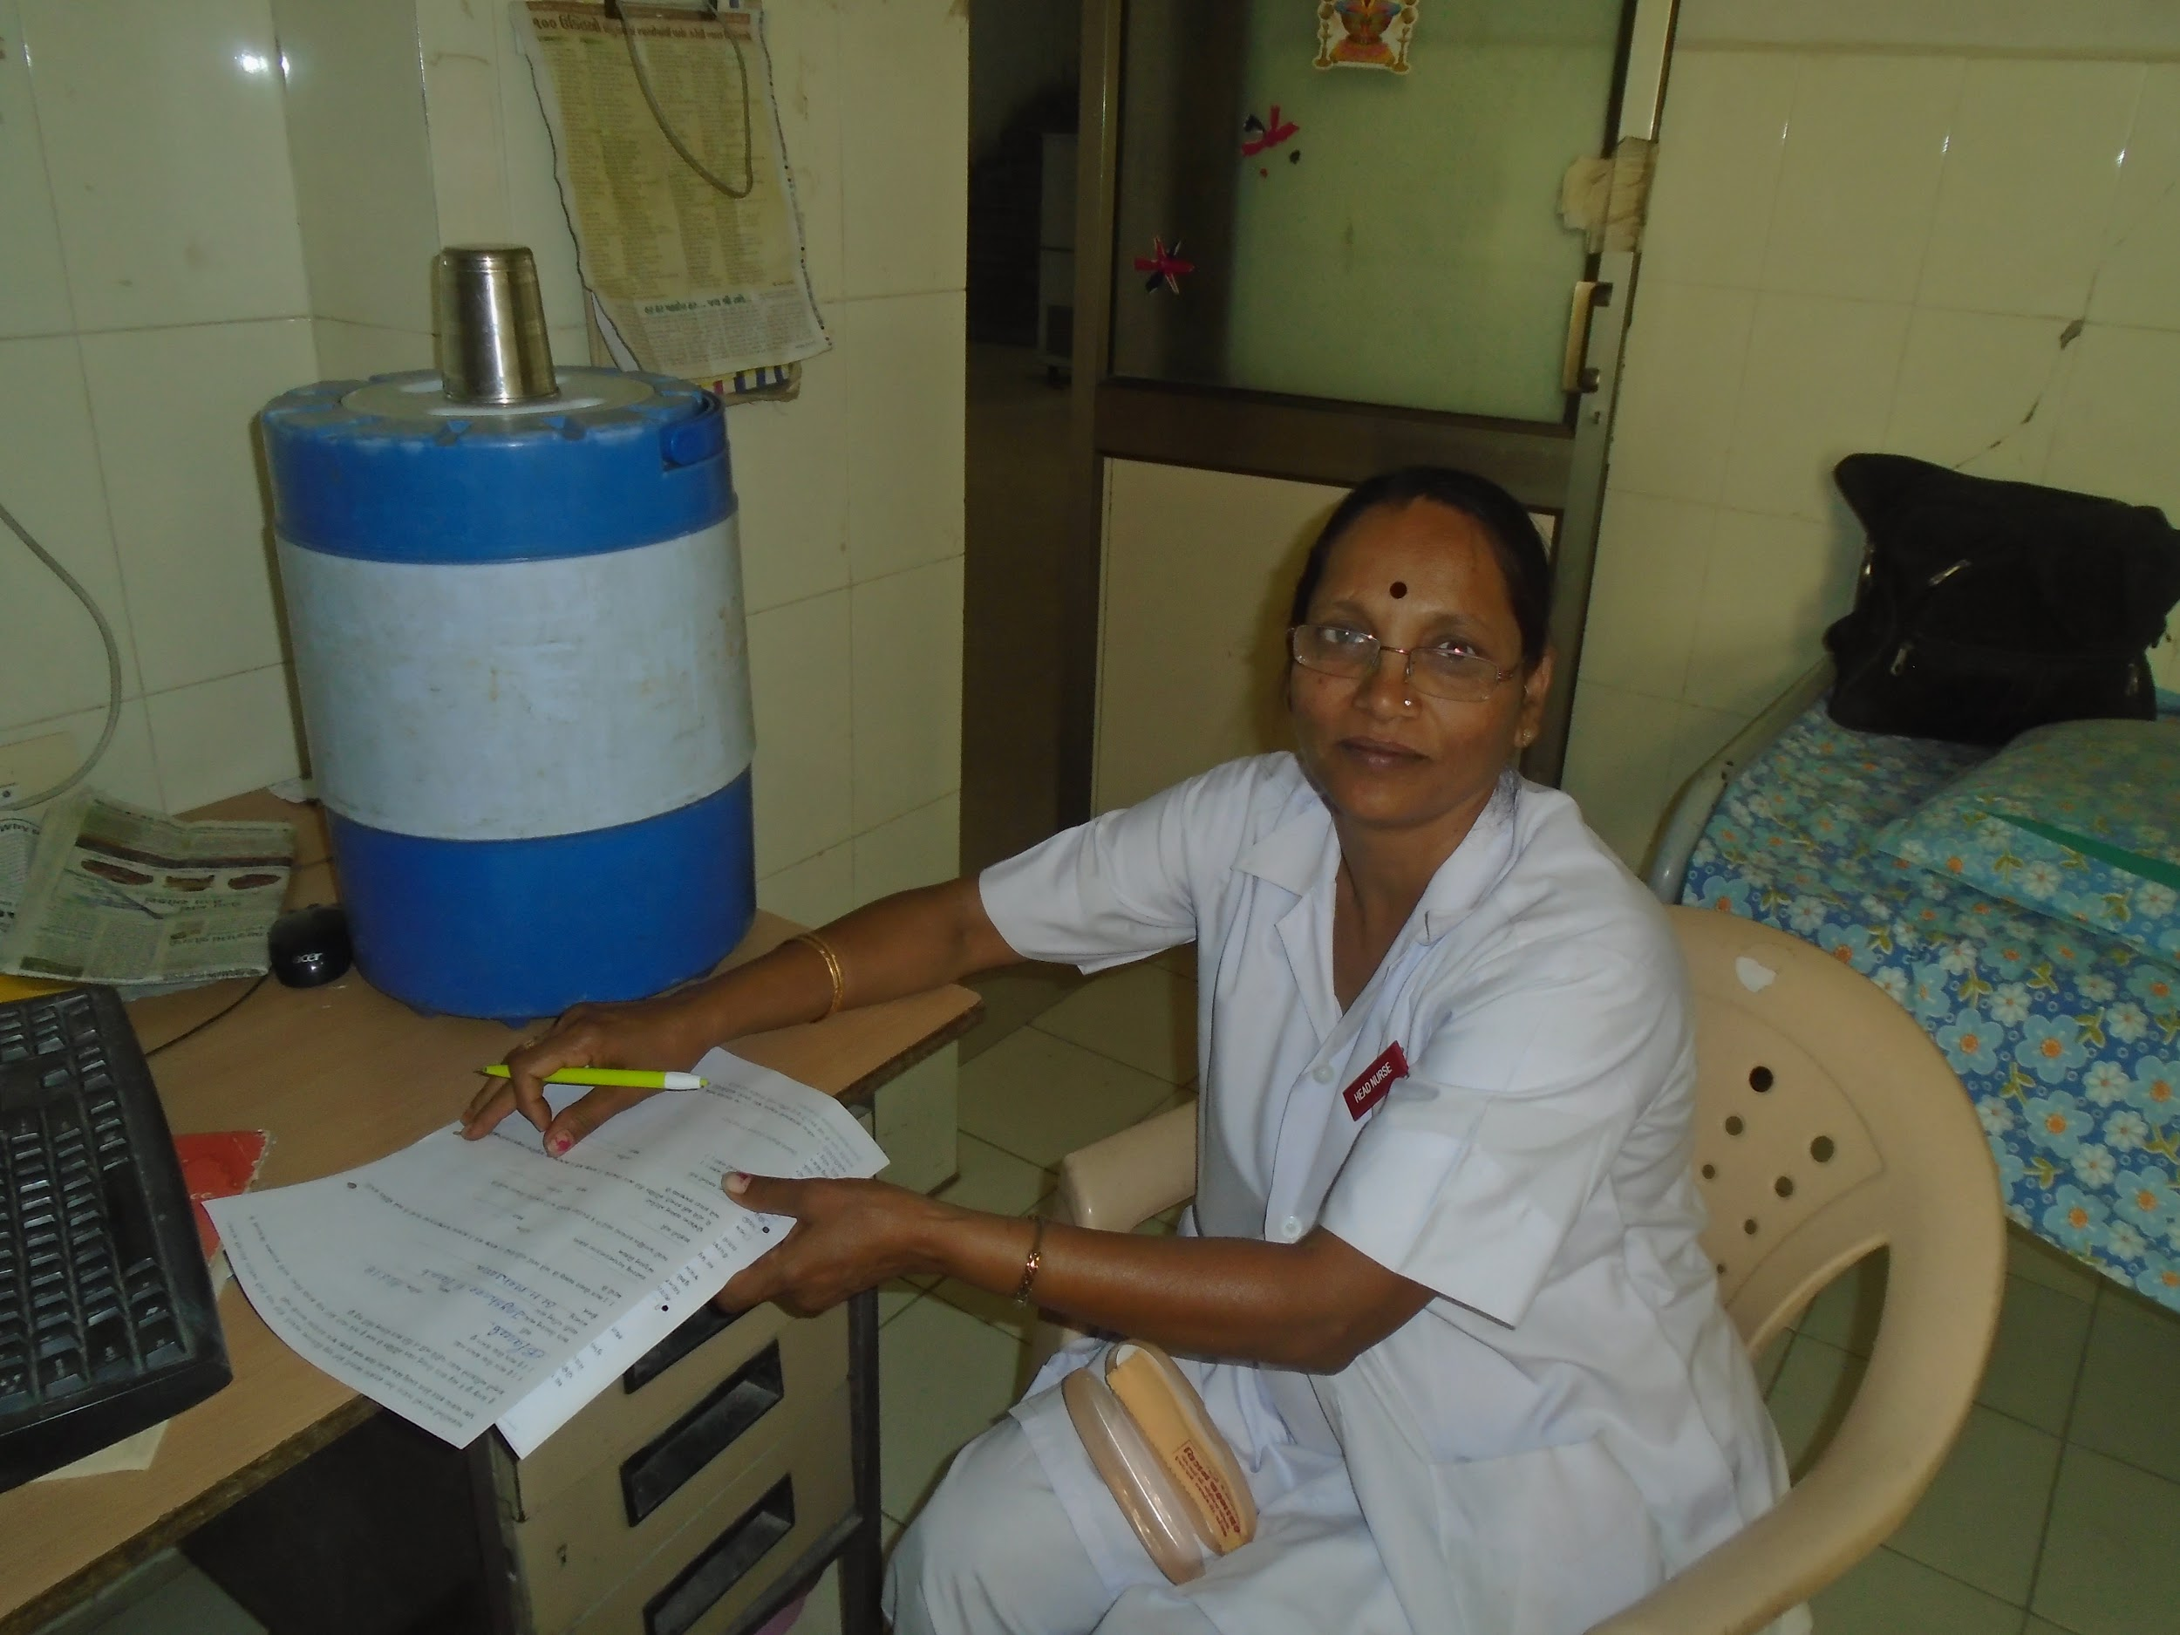

Ending discrimination and treating everyone equally
Jayshree Parab is a head nurse working in the emergency division of the General Health Hospital in Mehsana. The training has changed the way she receives people with psychosocial disabilities within her service. She and her colleagues now ensure that they engage and interact with them in the same way and on an equal basis with all other people coming to the General Health Hospital.
“I don't treat patients with mental illness and others patients differently anymore. I treat them both the same. This I have learnt through all my trainings. I have seen this change in the staff working in my ward as well. Earlier we all used to feel that we have to deal with “those” patients, as if they were different from all other patients. Now we have all started working together in treating them just like we would treat our other patients. We need to work with them as if they part of our own family...
If we treat them differently and as if they are someone else, it is not going to help. When try to include the patients this way, they will also feel supported. I feel that all these values need to be built into the system at the basic nursing training level in order to make a bigger impact.”
*****************

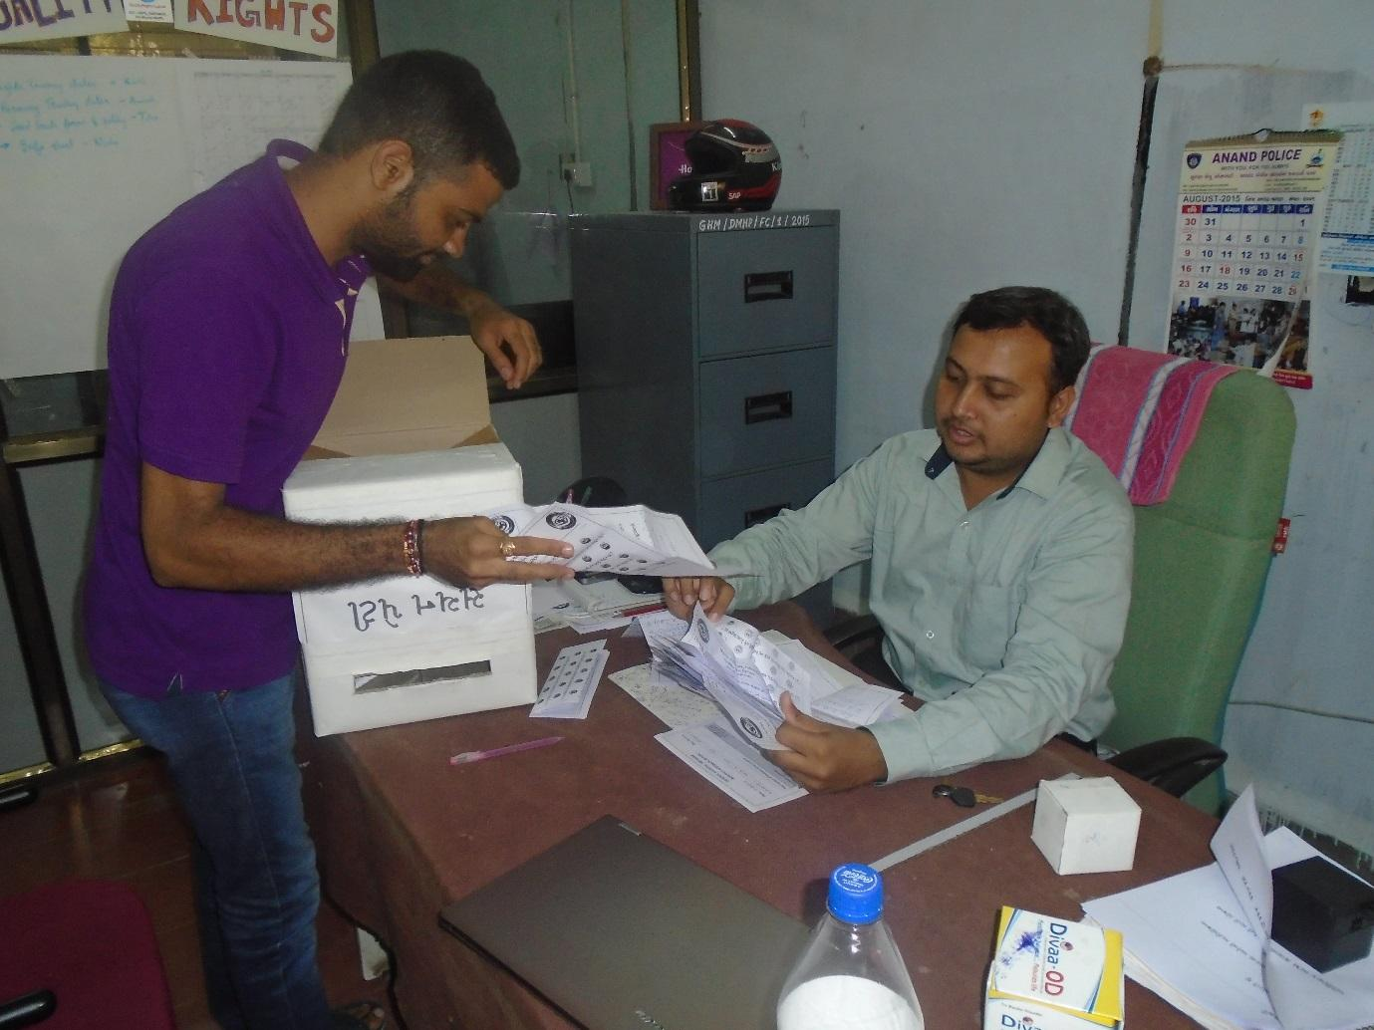
Improving the quality of care by listening to the advice and concerns of people using the service
Mr. Kartik Mistry and Dr. Animesh Patel are Mental Health Professionals at the General Hospital in Mehsana. Both are actively involved in improving the quality of care at the hospital and feel that the training has underscored the importance of listening to the advice and concerns of people using the service. Mr Mistry explains:
“After attending the human rights training as part of the QualityRights project, I feel strongly about a need to create a feedback policy in our facility...I think this will help us to improve our services and our relationship with the patients.”
*****************

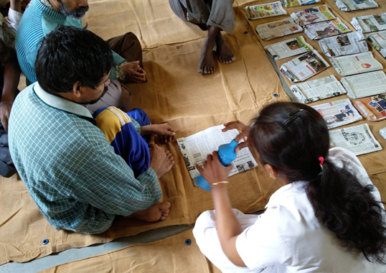
“The recovery training was enough for us to completely change our way of working”
Hetal Bhatti is a nurse who has been working at the Hospital for Mental Health, Bhuj for the past 3 years.
“We have changed so much!” is Ms. Bhatti’s response when asked about the changes at the hospital, since the start of QualityRights.
“When I came to the hospital, I was clueless. In all these years I felt that I was doing my duty well – giving medicines to patients. But that is all we did – giving medicines to all, even to those who did not want to take it”.
Ms. Hetal received capacity building to become a master trainer on recovery oriented care, along with her pee, Ms. Mita Shah. She recalls:
“If I have to think of how the change happened… I would trace it back to the recovery training. We learnt SO much. It was an eye opening experience for the two of us. It gave us a new direction in our practice”.
Soon, both Ms Hetal and Ms Shah became pioneers of change at the hospital.
“Having discussions, conversations, constant challenging of ideas, helped us convince the staff that recovery IS possible… even in case of severe mental illnesses.”
In the picture above, Ms Hetal is helping service users to make bags in the newly opened recreation room. She remarks:
“When we sit with them…the difference between “us and them” vanishes… However, earlier we were not like this. Forget about sitting with them, we wouldn’t even ask them to come near us.”
“ I am proud to say that we have several cases to quote. We haven’t done anything big… we have just managed to engage them in activity and to make them smile… I could name SO many patients who seem to be doing MUCH better than before. I am able to say this, despite much medical knowledge and expertise, just by looking at their smiling faces”.
Each day is different and challenging for Ms. Hetal. She continues to focus all her energy in making the hospital a better space for people using the services. She stresses that the major changes are not structural, but rather attitudinal. She explains:
“I don’t think outsiders will be able to tell… just by looking at the building. The change that has come about is more intangible … in our minds… The recovery training was enough for us to completely change our way of working. I feel that when the way you think changes, it automatically reflects in all spheres of your work. ”
*****************

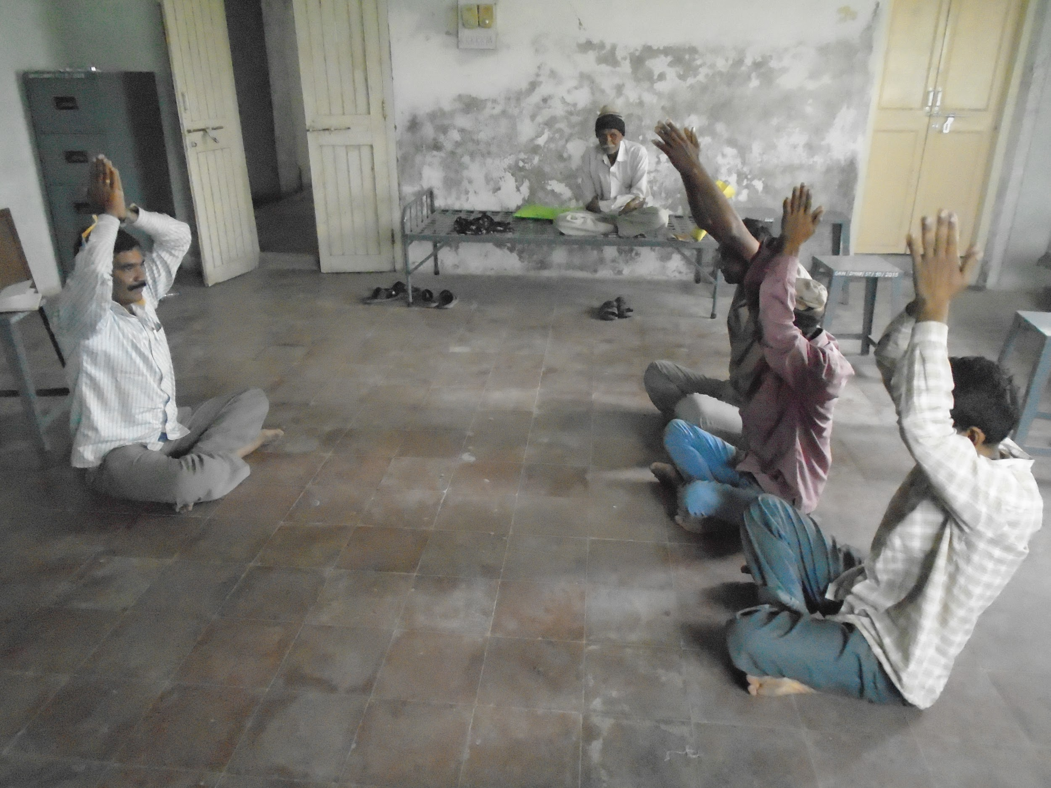 | 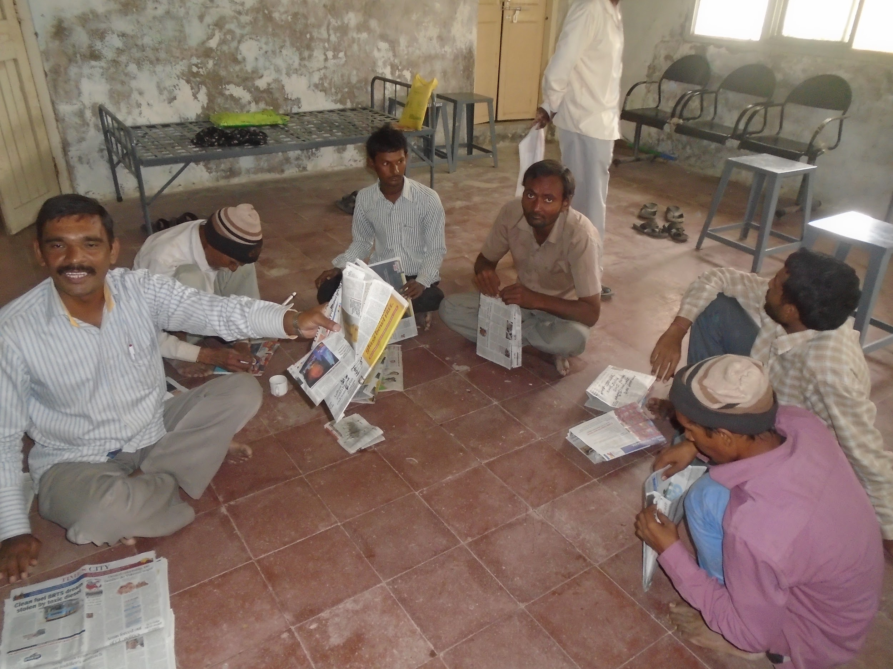
Service-users led yoga sessions | Service users engaging in a bag making workshop to develop skills for income generation

Peer Support Volunteers and staff working together to promote recovery
Equipped with new knowledge and skills received through the QualityRights training on recovery oriented care, staff and Peer Support Volunteers at Mehsana General Health Hospital have created a recovery room at the facility. People who have been excluded from many activities in their communities, now have a space where the can come and connect with each other and engage in activities that they have identified as being helpful to their recovery, such as physical exercise, yoga, and skills building around communication, income generation and self-care.

*****************

SUPPORTING AND COLLABORATING WITH PEER SUPPORT VOLUNTEERS
Collaborating with and supporting Peer Support Volunteers has also been an important area of focus for health and mental health practitioners since QualityRights Gujarat began. Staff members have been actively engaged in mentoring and training people with psychosocial disabilities to take up their role of PSVs.

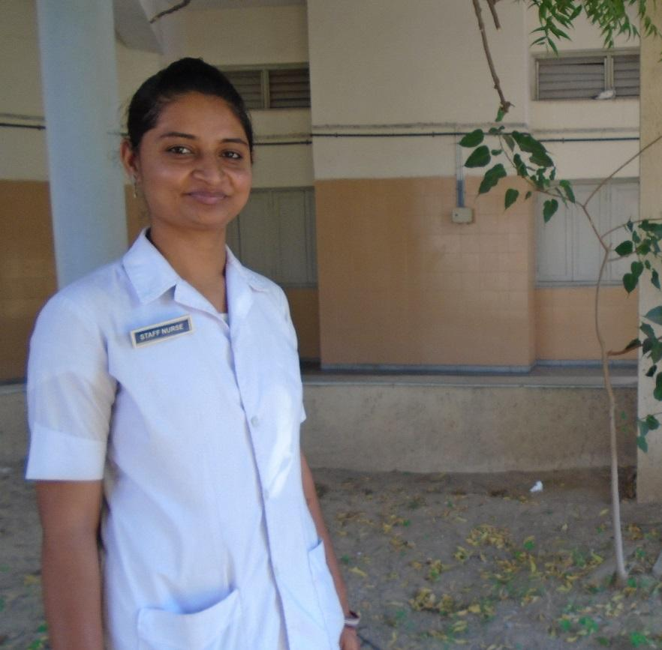

Empowering people using the services to take on new roles

Ms. Shabnam Mansuri, PSV mentor and master trainer on recovery-oriented care at the Hospital for Mental Health in Ahmedabad highlights that the mentoring process has not only empowered the PSVs but has also contributed to a sense of satisfaction among the mentors themselves.
“There has been a transition in them from service users to PSVs. I can see a sense of self confidence when they talk to me….being a mentor is a crucial role to play…I make substantial use of their time in the hospital. I support them in their personal issues as well. I believe that in every phase of their journey I can contribute by providing support and encouragement.”
******************

IMPLEMENTING PLANS TO IMPROVE QUALITY OF CARE AND HUMAN RIGHTS IN THE SERVICES
Another key intervention of QualityRights Gujarat was the assessment and improvement of conditions in services. Using the WHO’s QualityRights Assessment Tool Kit, committees made up of health care practitioners, people with psychosocial disabilities, families and other experts assessed the quality of care and human rights conditions in each of the project facilities. Following the assessments, the committees reported back their findings to each of the services. Subsequently, improvement plans have been developed and implemented at each of the services in order to address the gaps and problems identified in the assessment phase.

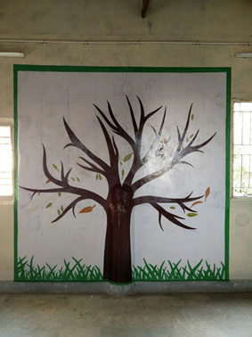

The Story of the Recreation room

As part of improvement efforts after the QualityRights assessments, the staff at Hospital for Mental Health in Bhuj took it upon themselves to turn an empty, dimly lit room into a space which can be used for many different activities including leisure, sports and relaxation activities, as well as a space for learning and skills building for income generation. With limited funds, the staff gathered a wood cutting machine, items for recreation, tables and chairs, paints for the room and other items. Today, something new is happening in the new room, every single day.
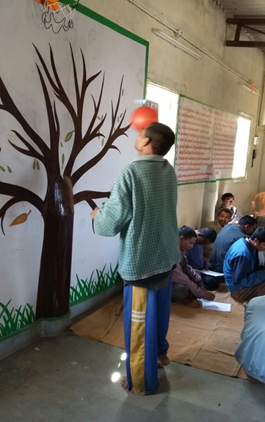

Bhaskarbhai (name changed) is a person using inpatient services at the Hospital. A physical condition has meant that he walks with a bent back, holding his knees, and this has been exacerbated by the fact the he fears he may fall if he walks without support. Consequently service staff have tended to provide him with food and medicines at his bedside. In addition, staff have found it difficult to communicate with Bhaskarbhai or support him because he is unable to express himself through words.
Nevertheless staff members wanted him to get involved in activities in the new recreation room, so every day, they started inviting him for prayer and exercise. Initially, they were sceptical about being able to get him to participate, since each time they approached him, he would refuse to get up from his bed. However after many failed attempts, he eventually started to acknowledge these invitations by looking at staff, instead of ignoring them.
One day, hearing the hustle and bustle in the room, he walked into to the room. One staff nurse recalls:
“He slowly balanced himself on his feet, let go off the support… and picked up the basketball. He then attempted to throw the ball into the basket. Once he hit the basket, he smiled at all of us and sat down on his usual chair in the corner. We could not believe our eyes!”.
Since then, Bhaskarbhai comes to the recreation room every day. He participates in the prayers and tries to do some of the exercises. Staff continue to encourage him to try walking without support. However, they understand that it will take time, support, and strength before Bhaskarbhai feels comfortable walking unaided.
Another nurse stresses:
“This is just ONE of the incidents… we have many more of these. There are so many patients who are benefiting in small and inconspicuous ways… However, these changes will add up… I am sure. When we see patients make even a small progress, we feel like we have done something for them. Through these examples we have learnt that those who do not communicate are the ones who need a lot of support. This is what we aim to do in the recreation room”.
******************

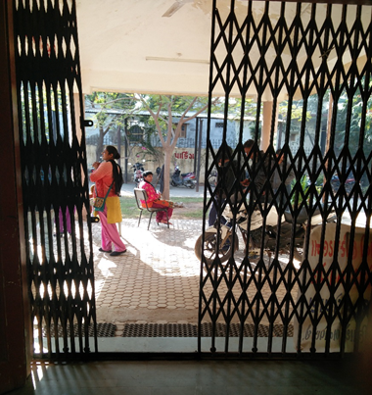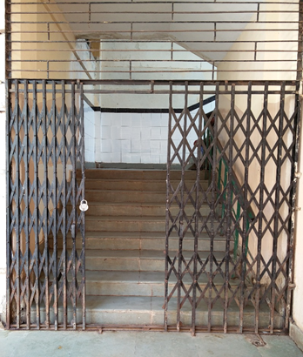

Breaking down barriers, gates and assumptions
One of the most prominent features of the Hospital for Mental Health, Bhuj are “the gates” – at the entrance of the facility itself and also at the entrance to the male ward. In 2014 when the QualityRights project began, these gates were locked throughout the day. In the case of the male ward, the men were allowed out only during meal time, after which they would be huddled up and asked to go back to their beds.
Once the core team was established to oversee the improvements within the service, one of their first agenda items was to look at making the hospital more safe and friendly. Discussions highlighted that the facility is constructed in an earthquake prone area and if an earthquake were to occur, all the people locked inside the wards would be at risk of injury or death.
One of the first activities planned by the core group was therefore to enable people to leave their wards. However this idea was initially met with resistance as staff feared that people using the service would run away.
However through open and ongoing discussions, and bolstered by the training provided on recovery oriented care and human rights, an understanding began to emerge that “taking risks” is a key part of the recovery process and that removing restrictions on people using services was a key means of promoting the rights of people using the services.
Staff also came to realise that much of the perceived ‘challenging behaviour’ that they witnessed from people using the service– getting angry, shouting, aggression, wanting to run away etc - was not due to their condition, but rather to the fact that they were locked up all day.
Initially, in order to reassure staff, only a few people were enabled to go outside of the gates for short periods of time. However over time everyone was able to move around freely, for hours at a time. Activities were also organised that people using the service could participate in.
The gates are still present at the facility. However, significant flexibility has been introduced into the rules concerning the use of the gates and they are no longer locked for long periods of time. In addition, staff attitude towards the importance of enabling people free movement has also changed. The ultimate aim is to move towards lock free hospital, which may take time. However, the foundation has been set.
******************

