How to improve treatment and care for persons with mental disabilities in line with the WHO recommendations and the CRPD – WHO training for mental health and related services in Croatia
As part of the WHO project on long-term institutions for adults with psychosocial and intellectual disabilities a training was held at the Neuropsychiatric hospital Ivan Barbot in Popovaca on 6 May 2019. The training was organized around the topic of how to improve treatment and care for persons with psychosocial and intellectual disabilities in line with the WHO recommendations and the CRPD.
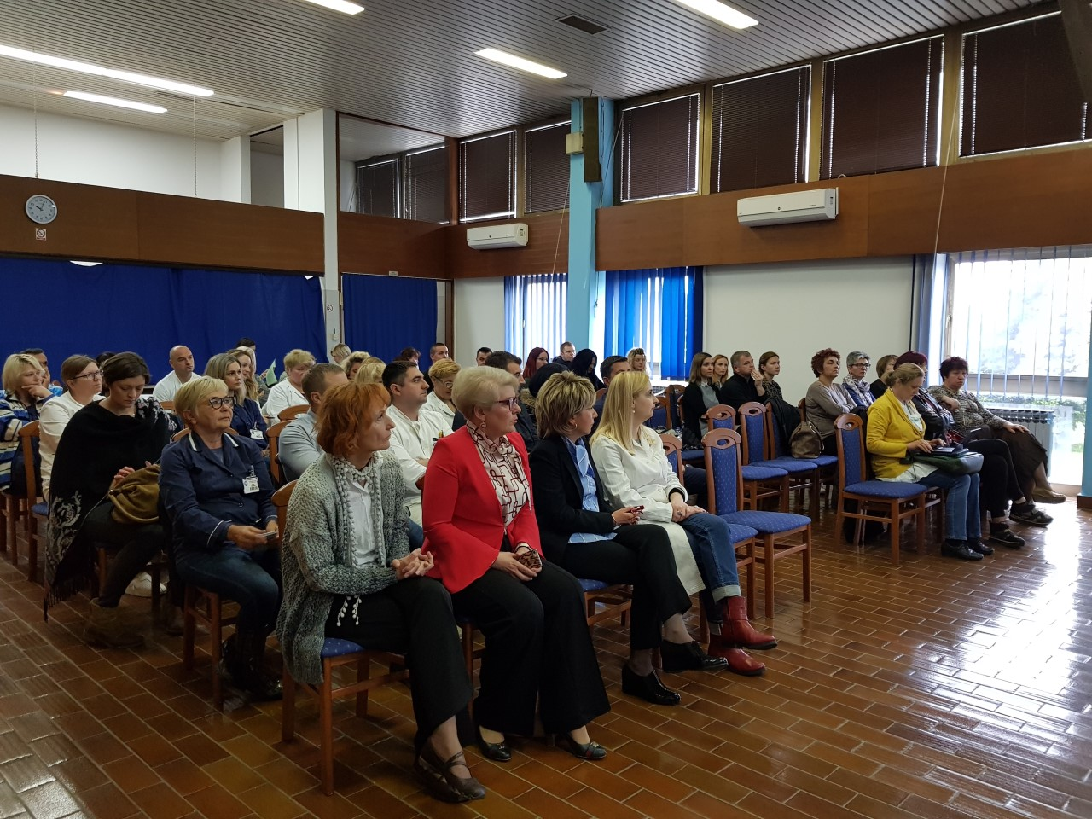

The head of the neuropsychiatric hospital Ivan Barbot Marina Kovac emphasised that the hospital chose to participate in the WHO project seeing it as a great opportunity to improve quality of service by implementing WHO recommendations.

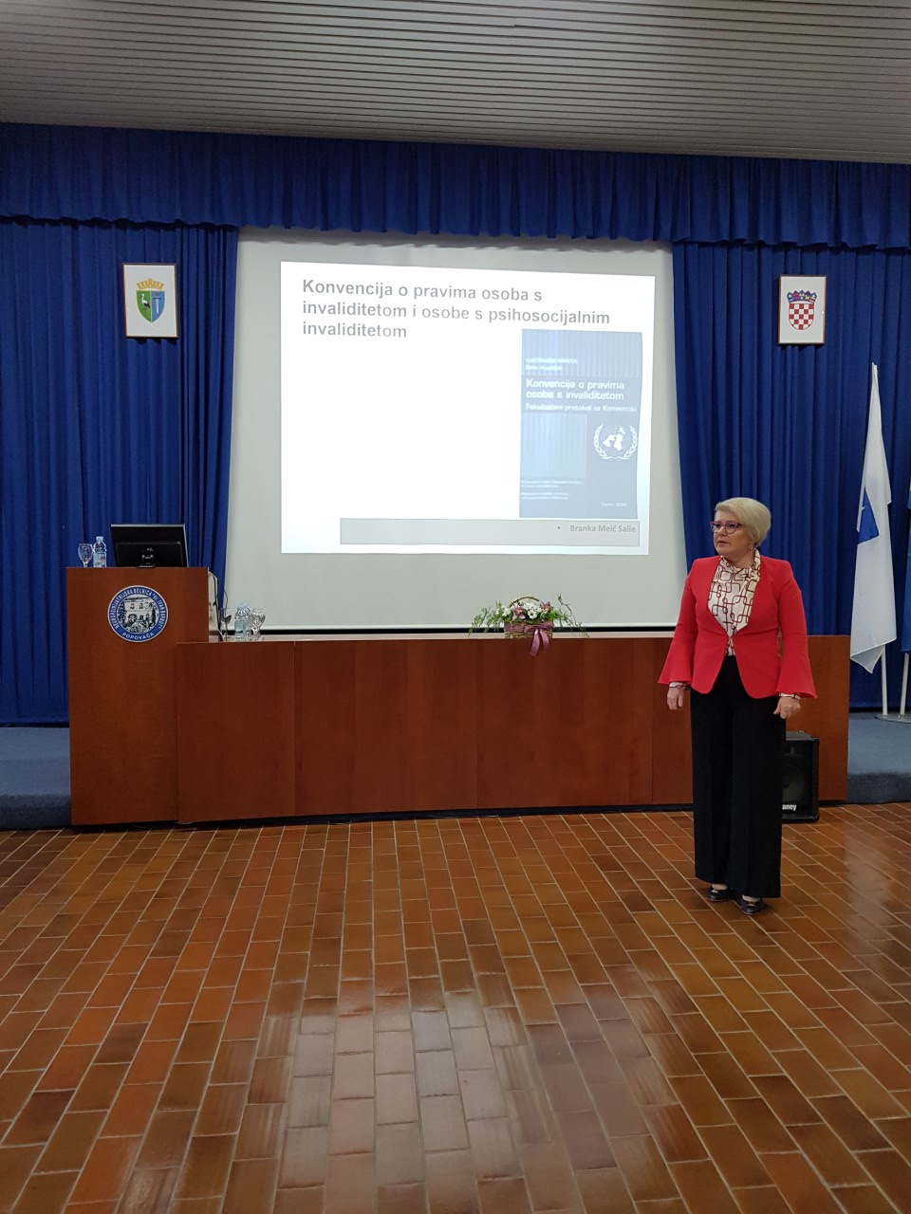

As part of the transformation process nine interdisciplinary work groups were formed at the hospital to screen the situation using the QualityRights toolkit and then develop an action plan to work on proposals and ideas on how to improve treatment, care and patient rights.
The training was attended by 58 participants. Staff from the psychiatric hospital Ivan Barbot were joined by representatives from the social care centers in the area, Croatian employment service and staff from the Association for promoting inclusion which provides assisted living arrangements for persons with intellectual disabilities and other support services for independent living in the community.

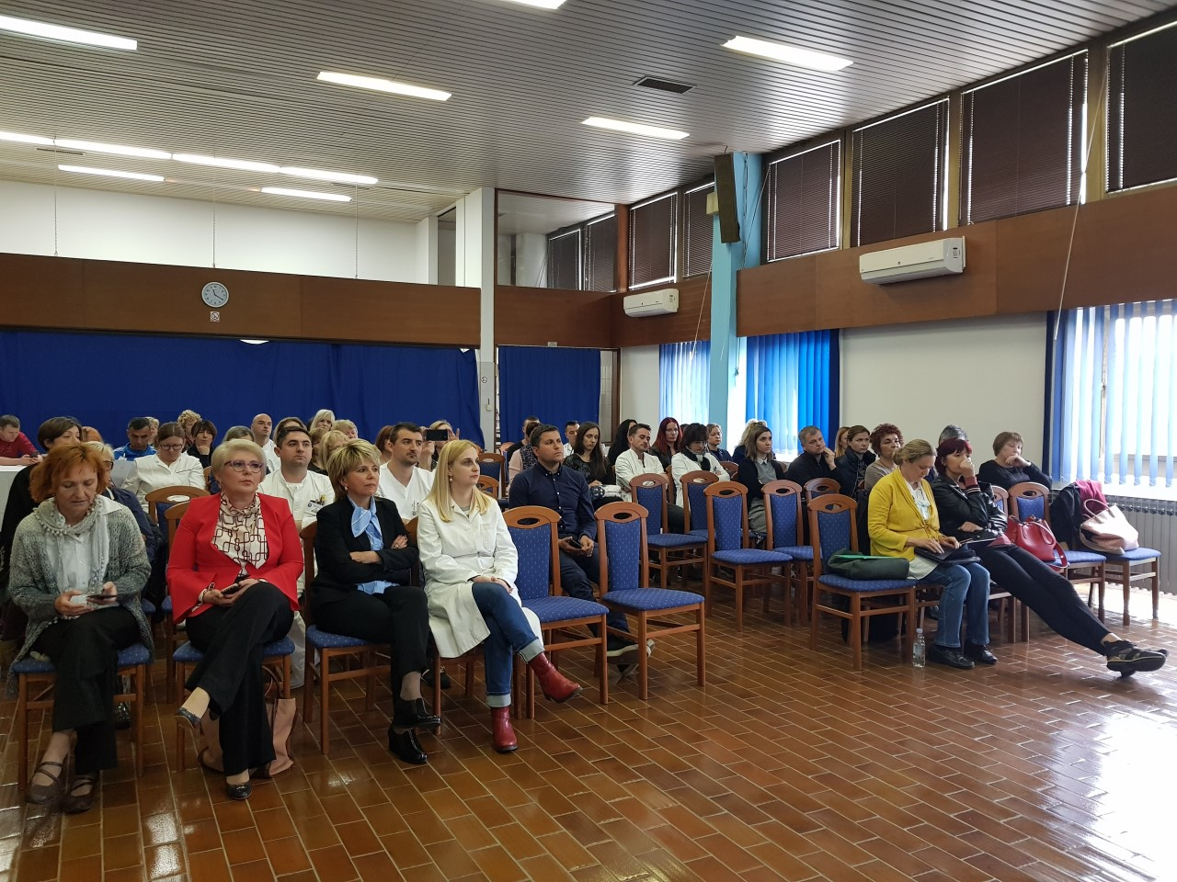

The training was delivered by the interdisciplinary national team coordinated by Tomislav Benjak from the Croatian public health institute.

The multidisciplinary team are Sladjana Strkalj Ivezic, a psychiatrist and the president of the Croatian society for clinical psychiatry, Neda Miscevic, a lawyer and representative of an organization for persons with intellectual disabilities (Association for promoting inclusion), Branka Meic Salie from a national human rights institution for persons with disabilities (Office of the ombudswoman for persons with disabilities) and Ivana Manic Milas from the Center for rehabilitation Stancic which has successfully undergone partial transformation into a service providing support for community-based living.

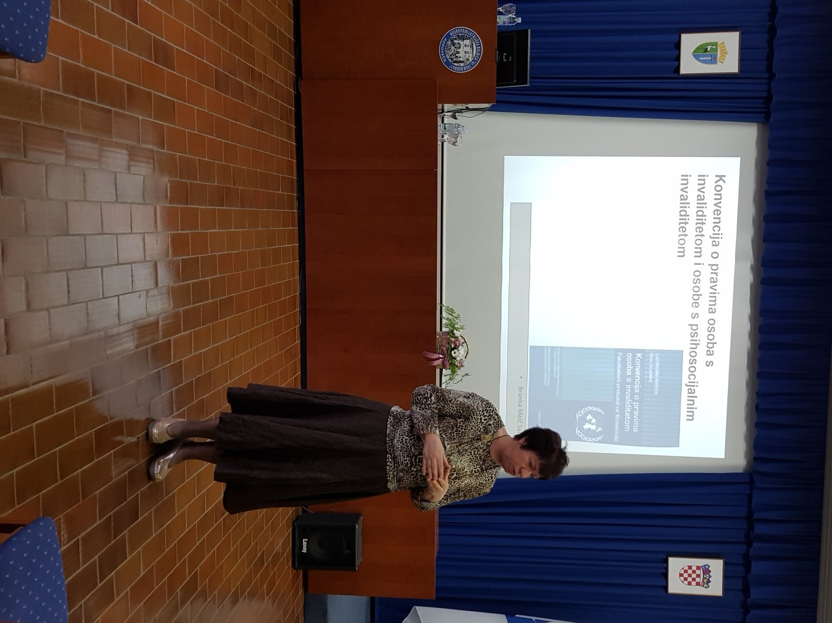

Professor Sladjana Strkalj Ivezic, president of the Croatian society for clinical psychiatry and the team leader greeted the participants and emphasised how timely the project has been connecting with the reform efforts at the national level and drafting of the national strategy for mental health which seeks to incorporate measures aimed at shifting care towards recovery-oriented and person-centered models, development of community-based treatment and support, protection of human rights and deinstitutionalisation.
Presentations during the training focused on a number of topics based on the QualityRights modules: understanding and promoting human rights in mental health, realising recovery and the right to health in mental health and related services, changing of the service culture and protecting the right to legal capacity and realising supported decision making.
Only 6 out of 58 participants reported hearing about the UN Convention on the rights of persons with disabilities or attending previous trainings on the Convention. Branka Meic Salie spoke about human rights as enshrined in the UN CRPD.

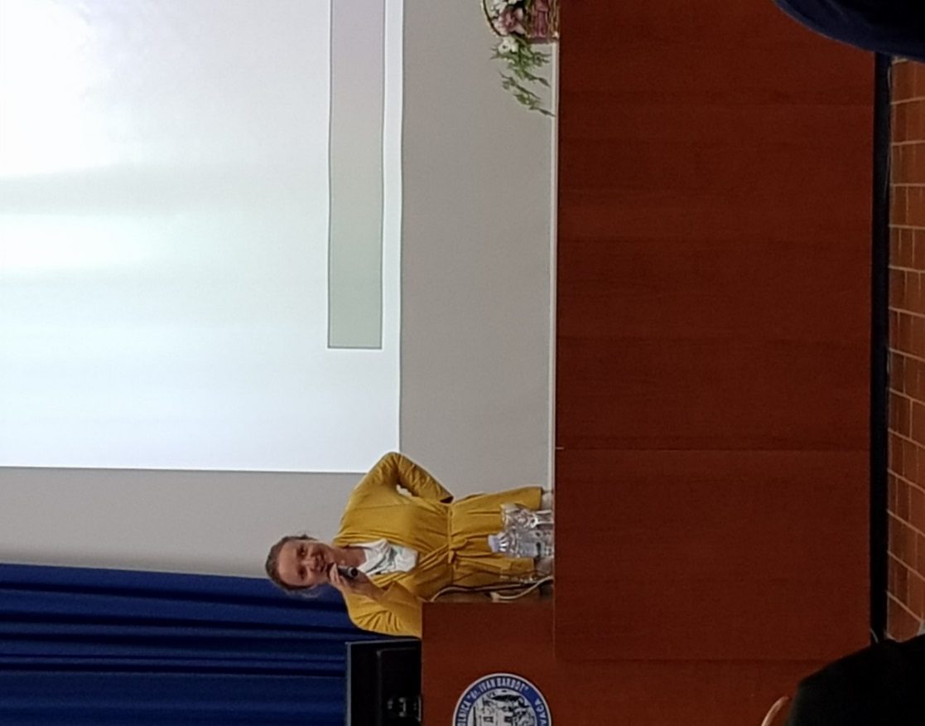

The participants were also introduced to the defintion of disability from the CRPD and the social and human rights model it introduces as well as reasonable accommodation and universal design as its tenets. The special emphasis was put on articles of key importance for persons with psychosocial and intellectaul disabilities: Art. 12, 14 and 19. It was pointed out that the CRPD didn't create any new human rights. We all have the same human rights but persons with disabilities have the right to support to exercise the same level of rights.
In her presentation WHO recommendations for transformation of mental health services in accordance with the recovery model and respect of human rights Sladjana Strkalj Ivezic emphasised the need for transforming the therapeutic culture of paternalism in which decisions are made for the person towards a culture that encourages autonomy, managing ones own life, building skills for fulfillment of various roles and social inclusion. In all this persons have the right to support which doesn't mean giving advice on what they should do but supporting them to make their own choices and explore different possibilities for realising their wishes. She spoke about treatment based on the indivual treatment plan and informed consent. She put a special emphasis on the right of the patient to withdraw the consent as well as the need to connect different mental health services and treatment and support plan upon leaving hospital as well as preventing coercion. Various outpatient treatment and support options need to be developed, in particular those that would facilitate a person's social inclusion. In conclusion, she added that treatment should be carried out in an encouraging therapeutic atmosphere which is empowering, stimulates the recovery process and promotes the human rights culture. She identified the shift in thinking towards the notion that recovery is possible as a main precondition for transformation of institutions.

Neda Miscevic spoke on the topic of Legal capacity, supported decision making and person-oriented planning for persons with intellectual disabilities. In addition, she informed the participants about the concept of human rights and the Croatian legal framework, deinstitutionalisation and inclusion. She emphasized that the UN CRPD is part of Croatian legal framework. However, in that framework persons with intellectual and/or mental disabilities who are persons with the so-called invisible disability are still mostly divested of legal capacity and different systems treat them differently as service users, wards under guardianship or patients under the Mental Health Act.

Although the UN CRPD states that persons with disabilities have the right to legal capacity as everyone else as well as the right to support to make their own decisions, substituted decision making still prevails in Croatia. Person-oriented planning plays an important role in decision making. Different services apply different techniques and methods pertaining to planning the future. Mental health services use recovery planning, institutions for long-term care use individual planning and community-based services apply person-oriented planning. Ms Miscevic demonstrated the technique as it is used by the Association for promoting inclusion and its support services active in 7 counties. In the end she emphasized that inclusion is a way of life and that every person with disability can and should live in the community with the appropriate support in accordance with his/her needs.
Ivana Mandic Milas spoke about the transformation of the Center for rehabilitation Stancic and change in the culture of the social services provision. Center Stancic was founded in 1956. Its transformation began in 2010, and it picked up pace in 2013 with the implementation of the Deinstitutionalization and spreading of community based social services project in 2013. As a result, the number of long-term residents has halved since 2004. Four new units have been established in the Zagreb county and the City of Zagreb. Currently there are 80 users of the supported living arrangement service and over 120 children and adults with disabilities use community-based services which contributes to the prevention of their institutionalization. The biggest obstacles that the Center had to overcome during the deinstitutionalization and transformation process were staff shortage, resistance of staff, parents/guardians and users towards change as well as the general impression of poor atmosphere and challenging the status quo in the functioning of the Center.
Over the past 10 years the Center implemented 10 projects which reinforced spreading of the community-based services. Currently two projects are being implemented funded by the EU structural funds. The project Improving provision of community-based social services has a value of 8.555.460,70 kuna and it will last for 30 months. The project Two steps forward has a value of 11.439.695,68 kuna and it will last for 36 months. As part of the project the following activities have been planned: equipping of the Daycare center for adults Dugo Selo 1 for occupational activities for users of supported living arrangement, reconstruction and equipping of a daycare center for users in the supported living programme in Jelkovec/ Zagreb, building and equipping of the daycare center Vrbovec for children with disabilities, equipping of the center for supporting persons with disabilities living in foster families and a unit for assisted living, procurement of a vehicle and equipment, employment and training of 13 new staff members as well as raising awareness in the community.

In the discussion following the training the participants raised the issue of resources and lack of staff and emphasized that the quality of service depends on available resources. More staff should be employed to ensure a better level of care while the present situation is that there is not even a bare minimum of staff. Another problem at the level of the system that was pointed out was lack of personalised support based on the actual needs of the person.
As part of the project leaflets were created with information about the involuntary and voluntary hospital admission, explanations of the informed consent, a leaflet on legal capacity and guardianship as well as the information about the UN Convention on the rights of persons with disabilities. The goal of these materials is to inform patients about their rights as well as promote the culture of voluntary treatment and upholding of human rights. The plan is to make these leaflets available to all mental health service users in cooperation with the Ministry of Health.

In the feedback form most participants stated that they found the training useful or very useful. They found it particularly useful to learn about alternative approaches to persons with psychosocial disabilities, the UN CRPD, transformation of the Center Stancic and inclusion. One of the things which was new to the participants was the information that a patient admitted to hospital on a voluntary basis can leave the treatment if they wish so as well as that informed consent should also be asked from patients admitted on involuntary basis.
Some of the participants said: We have to understand our patients and do not have to remove all of their symptoms. We can be more flexible with less fear that something bad will happen. We should encourage users to make decisions and take responsibility, respect their decisions and encourage self-advocacy and autonomy. It will be more difficult to implement the project in small rural communities. We would like to learn more about the waysin which we could convince a person who is not aware of his/her problems that cause her/him and his/her family suffering to seek medical help. We would like to visit the Center Stancic and learn more about the way they organise their work. From my personal experience I know how little patients know about their rights so I find the leaflets very useful. I would like to learn more about practical application and ways in which WHO guidelines can be implemented in everyday work.

